Calculating Bearings
Diagram NOT drawn to scale  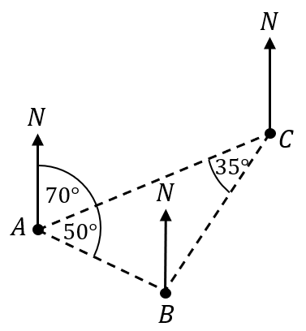 | (a) | (b) | (c)
 | Find the bearing of C from A | Find the bearing of B from A | Find the bearing of A from C
 | (d) | (e) | (f)
 | Find the bearing of C from B | Find the bearing of A from B | Find the bearing of B from C
Diagram NOT drawn to scale  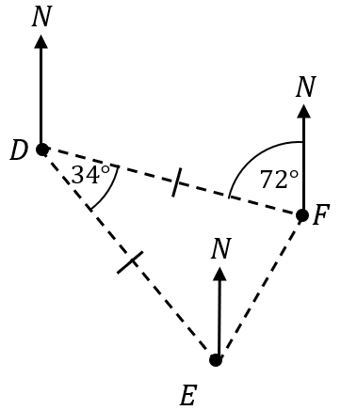 | (g) | (h) | (i)
 | Find the bearing of D from F | Find the bearing of F from D | Find the bearing of E from D
 | (j) | (k) | (l)
 | Find the bearing of E from F | Find the bearing of D from E | Find the bearing of F from E

