Exact Trigonometric Values in Right-Angled Triangles
(a) | (b) | (c)
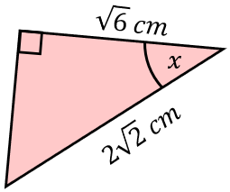  Find the exact value of $x$. | 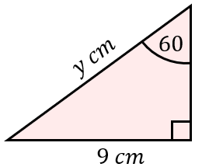  Find the exact length of $y$. | 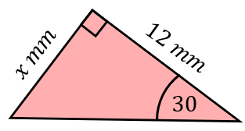  Find the exact length of $x$.
(d) | (e) | (f)
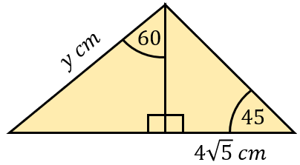  Find the exact length of $y$. | Find the exact length of $x$.  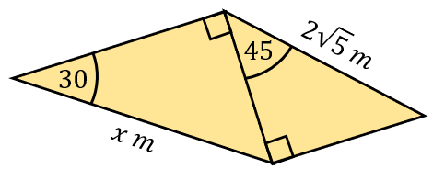 | 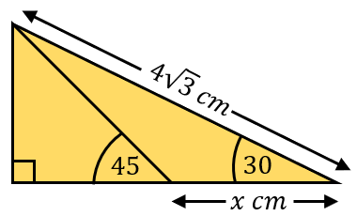  Find the exact length of $x$.
(g) | (h) | (i)
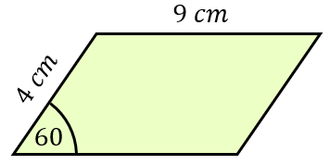  Find the area of the parallelogram. | Find the exact value of the shaded area.  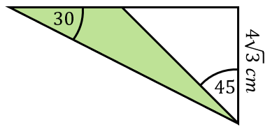 | 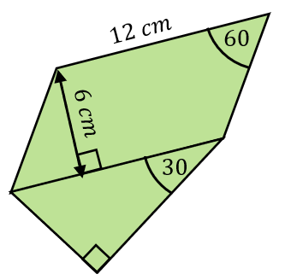  A triangle is joined to a parallelogram. Find the exact perimeter of the shape.

