Match-Up | Loci on an Argand Diagram

1 | 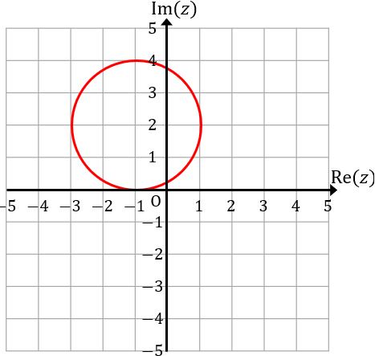 | 2 | 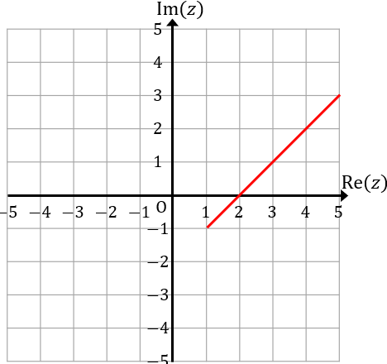 | 3 | 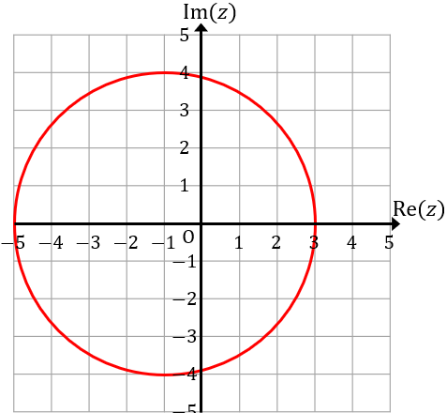
4 | 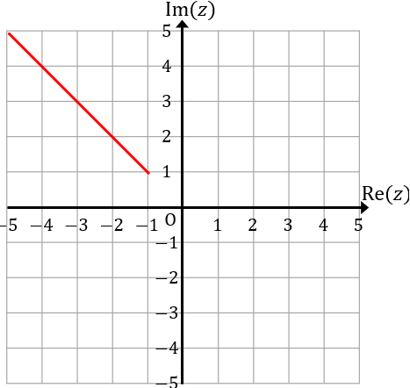 | 5 | 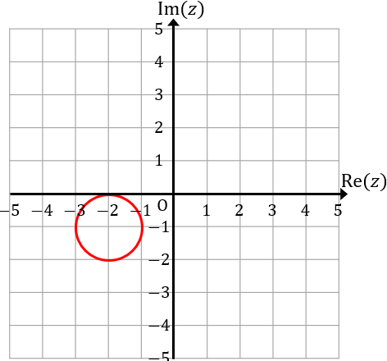 | 6 | 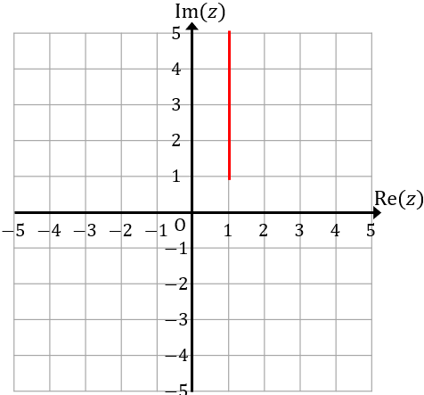
7 | 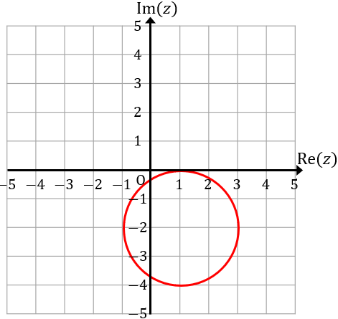 | 8 | 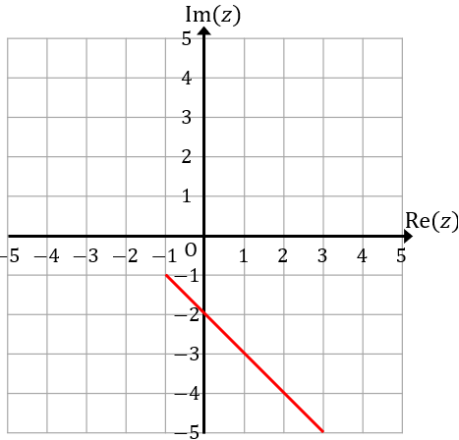 | 9 | 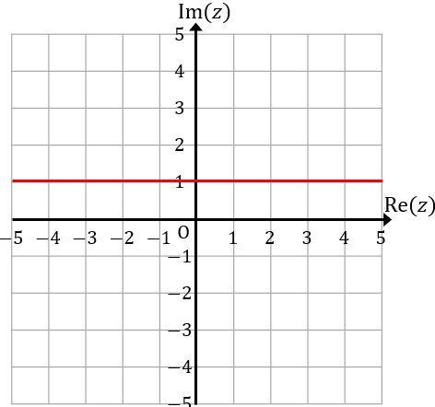
10 | 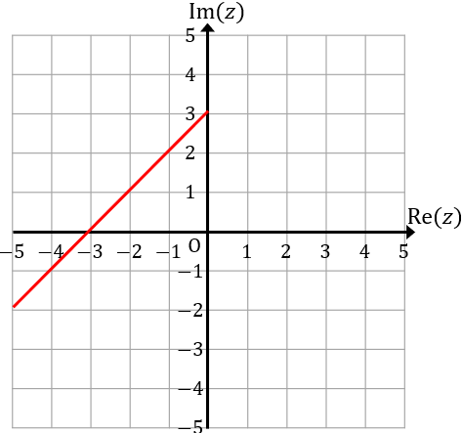 | 11 | 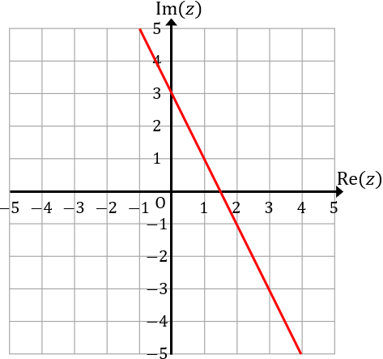 | 12 | 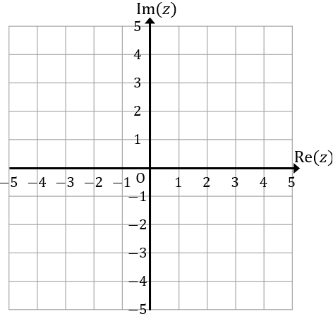

A | $$|z+2+i|=1$$ | B | $$\arg\left(z+1+i\right)=-\frac{π}{4}$$ | C | $$|z-1-2i|=1$$
D | $$\arg\left(z+1-i\right)=\frac{3π}{4}$$ | E | $$|z+1-2i|=2$$ | F | $$\arg\left(z-1-i\right)=\frac{π}{2}$$
G | $$\left|z-3i\right|=|z+i|$$ | H | $$\arg\left(z-1+i\right)=\frac{π}{4}$$ | I | $$\left|z+1\right|=|z-3-2i|$$
J | $$|z-1+2i|=2$$ | K | $$\arg\left(z-3i\right)=-\frac{3π}{4}$$ | L | $$\left|z+1\right|=4$$

1 | 2 | 3 | 4 | 5 | 6 | 7 | 8 | 9 | 10 | 11 | 12

