Line Symmetry
Add the number of squares specified so that the lines shown are all lines of symmetry
(a) | (b) | (c)
Add one square  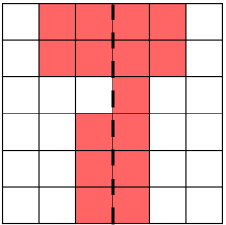 | Add two squares  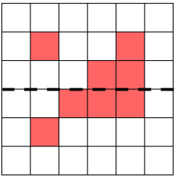 | Add three squares  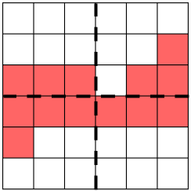
(d) | (e) | (f)
Add two squares  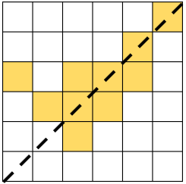 | Add three squares  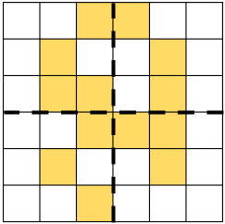 | Add two squares  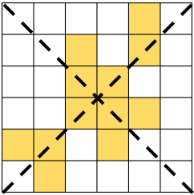
(g) | (h) | (i)
Add four squares  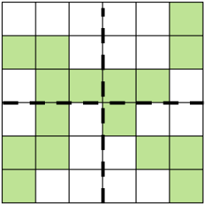 | Add two squares  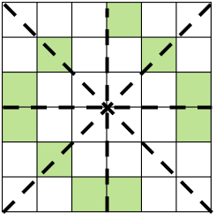 | Add three squares  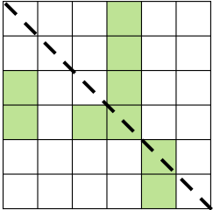
(j) | (k) | (l)
Add three squares  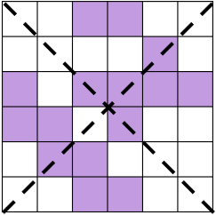 | Add four squares  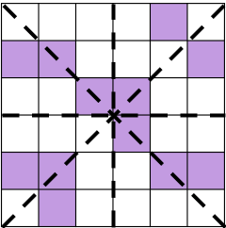 | Add four squares  