Finding Lengths Using Trigonometry

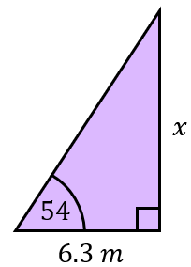
Find the missing lengths $x$.
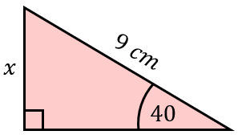
(a) (b)

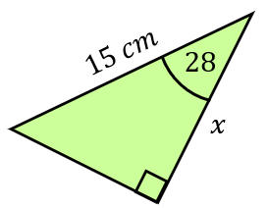
(c) (d)
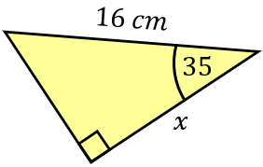

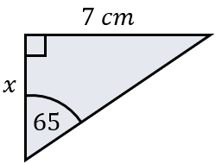
Find the missing lengths $x$.
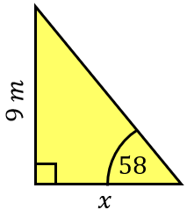
(e) (f)

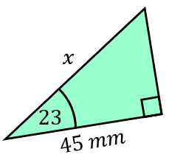
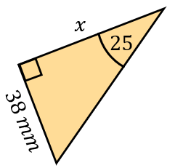
(g) (h)

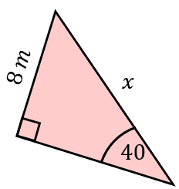
Find the missing lengths $x$.
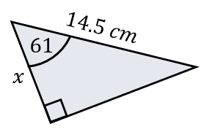
(i) (j)

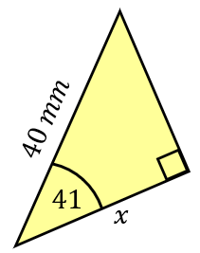
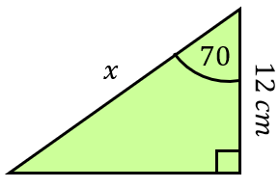
(k) (l)

Finding Lengths Using Trigonometry

Find the missing lengths $x$.
(a) (b)

(c) (d)

Find the missing lengths $x$.
(e) (f)

(g) (h)

Find the missing lengths $x$.
(i) (j)

(k) (l)

