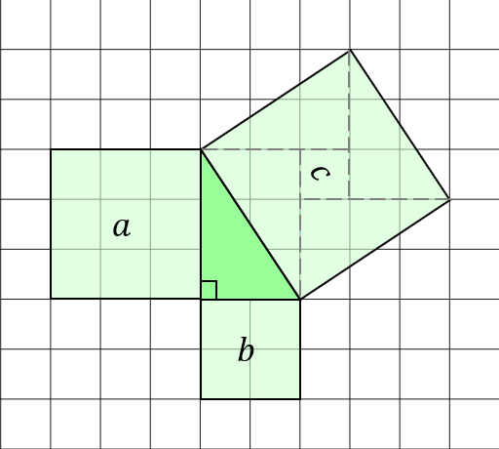
Investigating Right-Angled Triangles
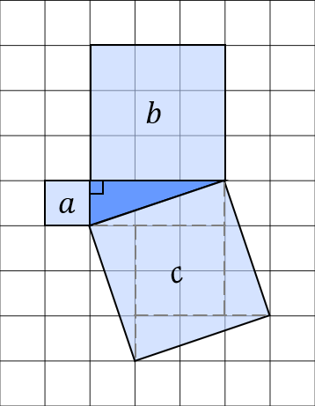
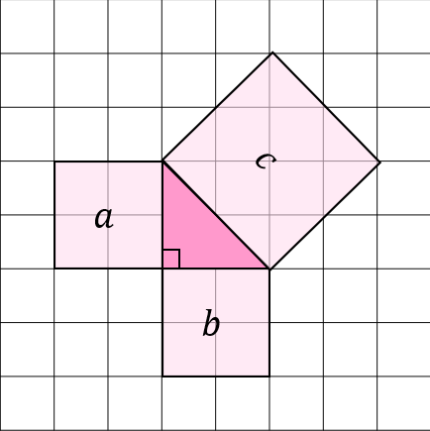
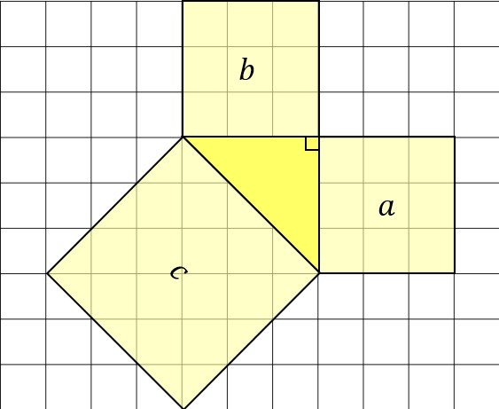
For each of the following right-angled triangles, find the areas of the squares attached to each of the sides.

Triangle | Area $a$ | Area $b$ | Area $c$
Pink
Blue
Green
Yellow

What do you notice? _____________________________
______________________________________________

