Quadratic Formula Problems in Context
(a) | (b) | (c)
A rectangle has a width of $(x+4) cm$, a length of $(x+1) cm$ and an area of $20 {cm}^{2}$. Show that $x^{2}+5x-16=0$ and hence find the value of $x$ to 1 decimal place. | The triangle shown has an area of $32 {cm}^{2}$. Show that $y^{2}+y-66=0$ and hence find the base and height of the triangle, both to 1 decimal place.  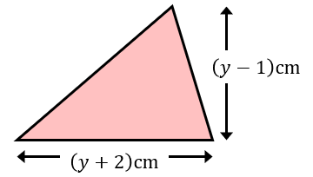 | The area of the compound shape is $80 {cm}^{2}$. By forming and solving a quadratic equation, find the value of $x$ to 1 decimal place.  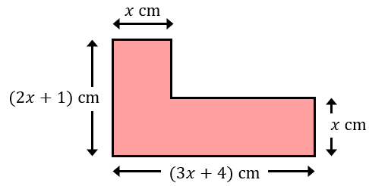
(d) | (e) | (f)
The right-angled triangle has sides of length $(x+4), (2x-1)$and  $(3x+2) cm$. Show that  $4x^{2}+8x-13=0$ and hence find the lengths of the sides of the triangle.  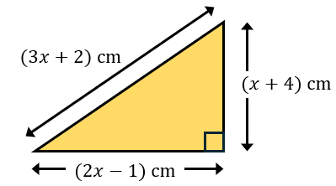 | Kalia thinks of a positive irrational number, which she rounds to 2 decimal places. When she squares the number then doubles it, it is $1.0752$ more than four times the number. By forming and solving a quadratic equation, find the number to 2 decimal places and the original irrational number Kalia thought of. | The total surface area of the cylinder shown is $300π {cm}^{2}$. By forming and solving an equation in $y$, find the radius of the cylinder to 2 decimal places.  