Crack the Code | Simplifying Expressions

A | 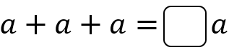 | B | 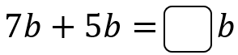
C | 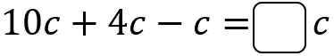 | D | 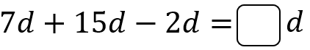
E | 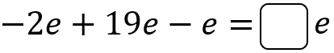 | F | 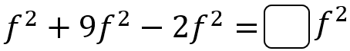
G | 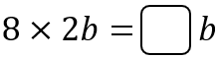 | H | 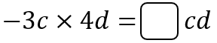
I | 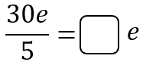 | J | 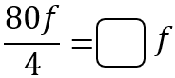
K | 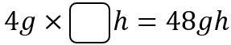 | L | 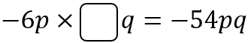
M | 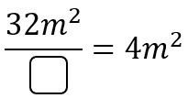 | N | 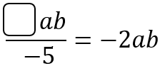
P | 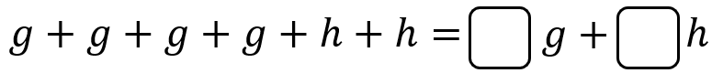
Q | 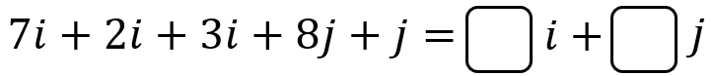
R
S | 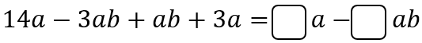
T | 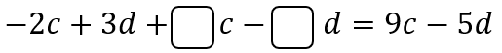
U | 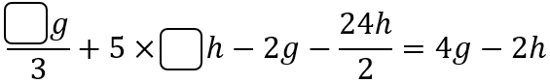
To get the three-digit code, add together all your answers.

