Solving Quadratic Equations Problems
(a) | (b) | (c)
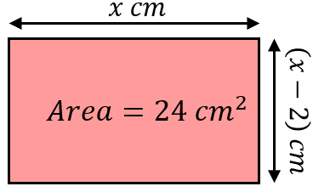  (i) Show that $x^{2}-2x-24=0$  (ii) Hence find the length and width of the rectangle. | 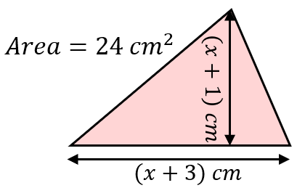  (i) Show that $x^{2}+4x-45=0$  (ii) Hence find the width and height of the triangle. | 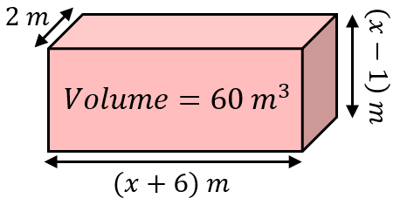  (i) Show that $x^{2}+5x-36=0$  (ii) Hence find the dimensions of the cuboid.
(d) | (e) | (f)
Find the value of $x$ and hence the dimensions of the trapezium. Show clear algebraic working.  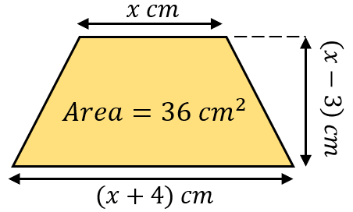 | Find the value of $x$ and hence the dimensions of the compound shape. Show clear algebraic working.  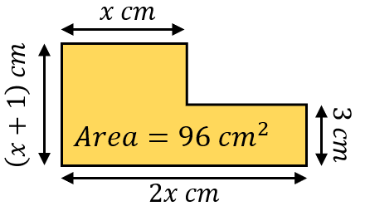 | Find the value of $x$ and hence the dimensions of the cuboid. Show clear algebraic working.  