Fill In The Blanks…
Factorising by Taking Out Common Factors

Expanded Expression | HCF of Numbers | HCF of Variables | Factorised Expression
$$7x+14$$ | $$7$$ |  | $$7(x+2)$$
$$20+30a$$ | $$10$$ |  | 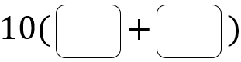
$$15b-5$$ | $$5$$
$$12x+15$$
$$30a-12b$$
$$8cd+de$$ |  | $$d$$ | 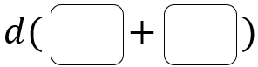
$$10a+ab$$
$$x^{2}-5x$$ |  | $$x$$
$$6x^{2}+xy$$
$$4ab+8b$$ | $$4$$ | $$b$$ | 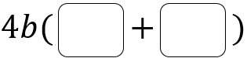
$$10cd-25de$$ | $$5$$ | $$d$$
$$4x^{2}+2x$$
$$14xy-21x^{2}$$
$$6x+3-9y$$
$$5x^{2}-10xy+20x$$
$$24a^{2}b+16abc$$
$-18xyz$ |  |  | 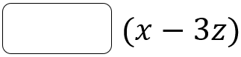
 |  |  | 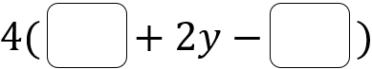
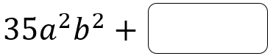 |  |  | 