Drawing Line Segments with a Given Gradient
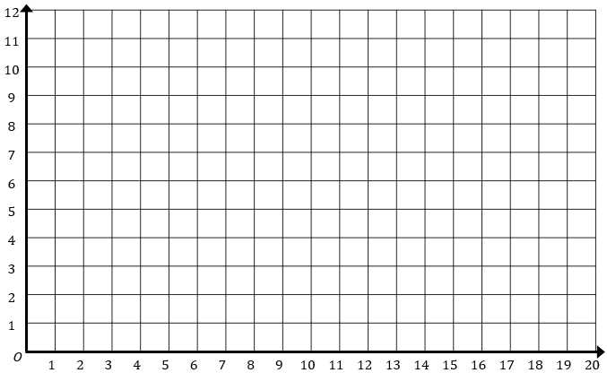
1 | Starting at the point $(0, 2)$, draw a line segment with gradient $1$
2 | Starting at the point $(16, 12)$, draw a line segment with gradient $-2$
3 | Starting at the point $(0, 0)$, draw a line segment with gradient $\frac{1}{3}$
4 | Starting at the point $(5, 6)$, draw a line segment with gradient $\frac{3}{4}$
5 | Starting at the point $(1, 11)$, draw a line segment with gradient $-4$
6 | Starting at the point $(3, 10)$, draw a line segment with gradient $0$
7 | Starting at the point $(9, 1)$, draw a line segment with gradient $\frac{5}{3}$
8 | Starting at the point $(12, 9)$, draw a line segment with gradient $-\frac{1}{2}$
9 | Starting at the point $(15, 5)$, draw a line segment with gradient $-\frac{4}{5}$
10 | Starting at the point $(10, 0)$, draw a line segment with gradient $\frac{2}{7}$

