Fill in the Blanks | Evaluating Composite Two-Step Functions

Question | Input | 1st Function |  | 2nd Function |  | Output | Answer
$$f\left(x\right)=x^{2}+2$$  $$g\left(x\right)=3x-1$$  Find $fg(4)$ | 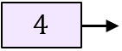 | 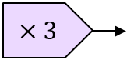 | 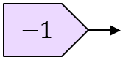 | 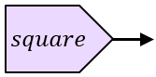 | 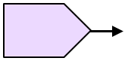 |  | $$fg\left(4\right)=$$
$$f\left(x\right)=3\sqrt{x}$$  $$g\left(x\right)=2x+5$$  Find $gf(9)$ |  | 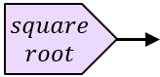 |  |  |  |  | $$gf\left(9\right)=$$
$$f\left(x\right)=\frac{1}{x}-3$$  $$g\left(x\right)=2x+4$$  Find $fg(-1)$ |  |  |  |  |  |  | $$fg\left(-1\right)=$$
$$g\left(x\right)=\frac{x}{2}+1$$
$$h\left(x\right)={4x}^{2}$$
Find $hg(0.5)$
$$f\left(x\right)=x^{2}+3$$
$$g\left(x\right)=2x-7$$
Find $fg(5)$

