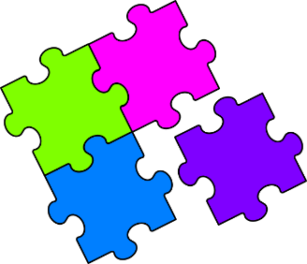
Match-Up
Improper Fractions and Mixed Numbers

1 | $$2\frac{1}{2}$$ |  | 6 | $$1\frac{5}{6}$$ |  | 11 | $$7\frac{2}{3}$$ |  | 16 | $$3\frac{5}{8}$$
2 | $$1\frac{2}{3}$$ |  | 7 | $$10\frac{1}{2}$$ |  | 12 | $$8\frac{1}{4}$$ |  | 17 | $$5\frac{1}{2}$$
3 | $$2\frac{3}{4}$$ |  | 8 | $$4\frac{3}{8}$$ |  | 13 | $$5\frac{1}{6}$$ |  | 18 | $$2\frac{4}{5}$$
4 | $$1\frac{3}{7}$$ |  | 9 | $$3\frac{1}{3}$$ |  | 14 | $$1\frac{6}{7}$$ |  | 19 | $$11\frac{3}{4}$$
5 | $$3\frac{1}{5}$$ |  | 10 | $$5\frac{3}{4}$$ |  | 15 | $$3\frac{3}{5}$$ |  | 20 | $$3\frac{5}{7}$$
A | $$\frac{11}{2}$$ |  | F | $$\frac{10}{7}$$ |  | K | $$\frac{11}{4}$$ |  | Q | $$\frac{21}{2}$$
B | $$\frac{33}{4}$$ |  | G | $$\frac{16}{5}$$ |  | L | $$\frac{13}{7}$$ |  | R | $$\frac{5}{3}$$
C | $$\frac{23}{3}$$ |  | H | $$\frac{23}{4}$$ |  | M | $$\frac{5}{2}$$ |  | S | $$\frac{29}{8}$$
D | $$\frac{11}{6}$$ |  | I | $$\frac{18}{5}$$ |  | N | $$\frac{35}{8}$$ |  | T | $$\frac{14}{5}$$
E | $$\frac{26}{7}$$ |  | J | $$\frac{10}{3}$$ |  | P | $$\frac{31}{6}$$ |  | U | $$\frac{47}{4}$$

1 | 2 | 3 | 4 | 5 | 6 | 7 | 8 | 9 | 10
11 | 12 | 13 | 14 | 15 | 16 | 17 | 18 | 19 | 20

