Crack the Code | Integrating using Partial Fractions

A | 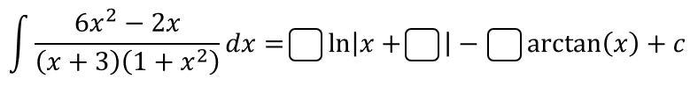
B | 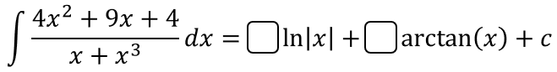
C | 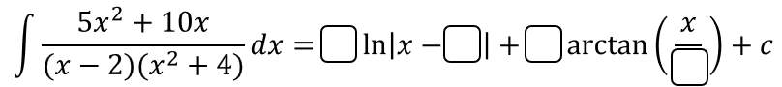
D | 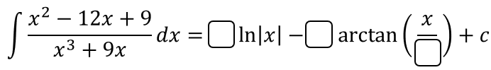
E
F
G | 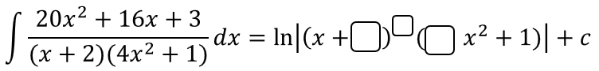
H | 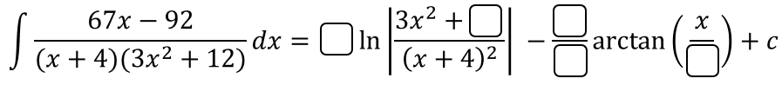
To get the three-digit code, add together the numbers in the boxes.

