Plotting Harder Non-Linear Graphs
(a) | (b) | (c)
Plot the graph of $y=x^{2}+\frac{2}{x^{2}}$  between $x=0.5$ and $x=3.5$ | Plot the graph of $y=x^{3}+3x+\frac{2}{x}$ from $x=0.1$ to $x=1.5$ | Plot the graph of $y=x\left(\frac{x}{2}-\frac{1}{x^{2}}\right)$  from $x=-4$ to $x=-0.5$
$$x$$ $$0.5$$ $$1$$ $$1.5$$ $$2$$ $$2.5$$ $$3$$ $$3.5$$  $$y$$ | $$x$$ $$0.1$$ $$0.2$$ $$0.4$$ $$0.7$$ $$1$$ $$1.2$$ $$1.5$$  $$y$$ | $$x$$ $$-4$$ $$-3$$ $$-2$$ $$-1$$ $$-0.5$$ $$-0.25$$  $$y$$
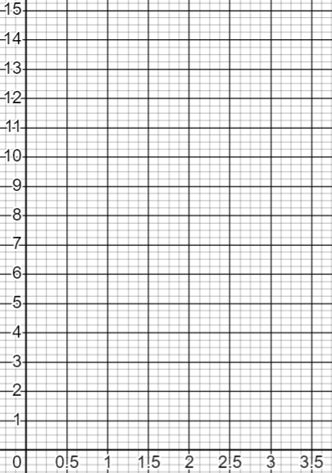 | 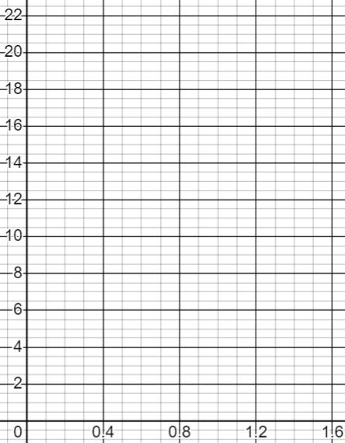 | 