Geometry Revision |  |  |  | 5
(a) | (b) | (c) | (d)
A metal cube of side length $8 cm$. The density of the metal is $7.48 g/{cm}^{3}$. Find the mass of the metal cube. | On the grid, enlarge shape A by a scale factor of $2$ about centre $(1, 2)$  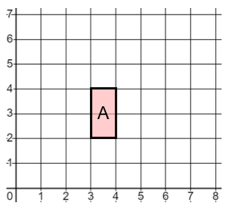 | The diagram shows three regular pentagons joined together. Work out the value of angle $x$.  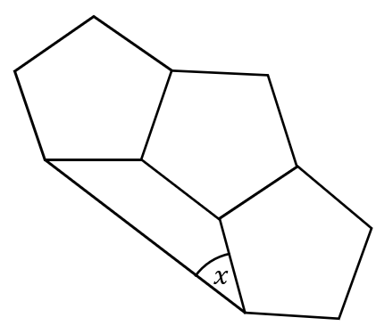 | Work out the missing length $x$.  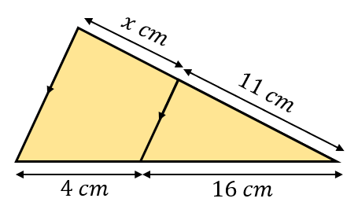
(e) | (f) | (g) | (h)
(i) Convert $4500 {cm}^{2}$ into $m^{2}$  (ii) Convert $0.085 {cm}^{3}$into ${mm}^{3}$ | $$\vec{OA}=\left(\begin{matrix}4 \\ 3\end{matrix}\right) \vec{OB}=\left(\begin{matrix}-2 \\ 7\end{matrix}\right)$$  Find $\vec{AB}$ as a column vector | Work out the size of angle $x$. Give reasons for your answer.  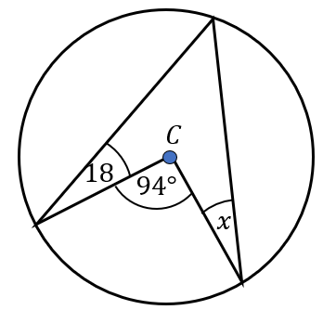 | The total surface area of the hemisphere is equal to the total surface area of the cylinder. Find the height $h$.  