Volume and Surface Area of Prisms

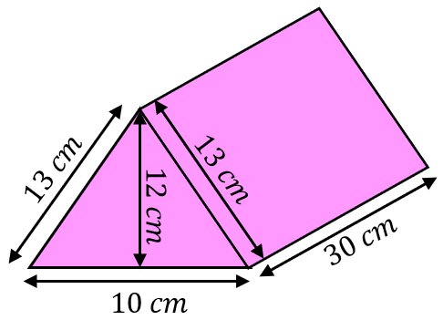
Find the volume and surface area of each of these prisms.
(a)

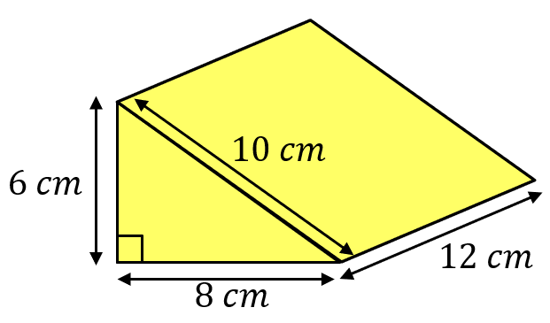
(b)

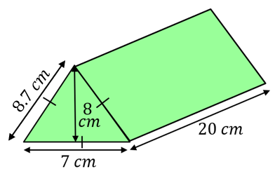
(c)

Find the volume and surface area of these prisms.
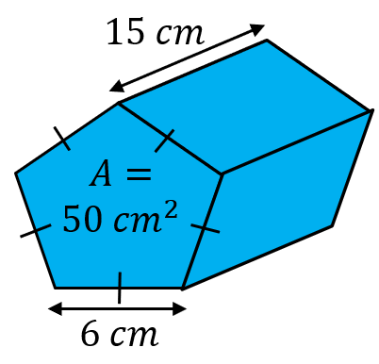
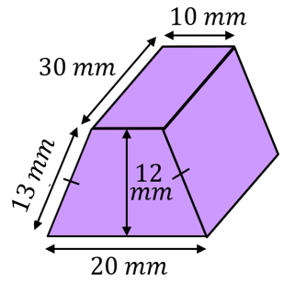
(a) (b)

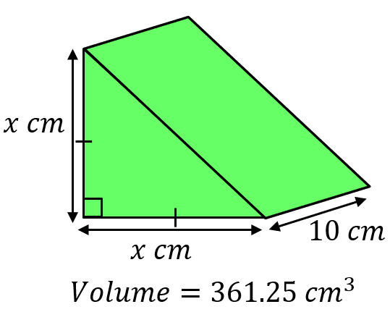
Find the missing lengths.
(a) (b)

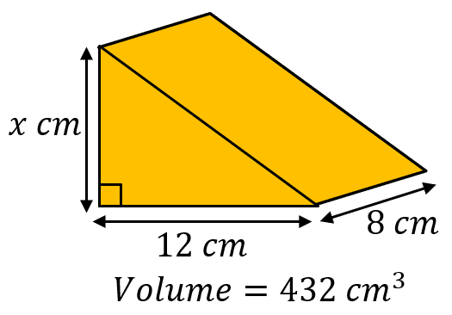

Volume and Surface Area of Prisms

Find the volume and surface area of each of these prisms.
(a)

(b)

(c)

Find the volume and surface area of these prisms.
(a) (b)

Find the missing lengths.
(a) (b)

