Volume and Surface Area of Compound Curved Shapes
(a) | (b)
Find the volume and surface area of the compound shape.  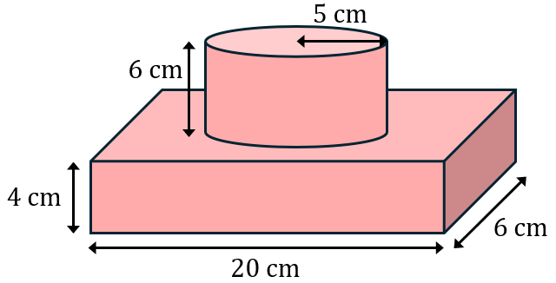 | Find the volume and surface area of the compound shape.  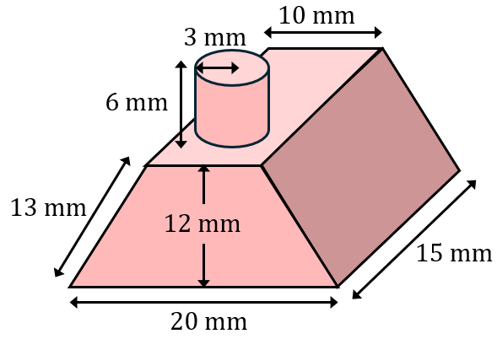
(c) | (d)
Find the volume and surface area of the semi-cylinder shown.  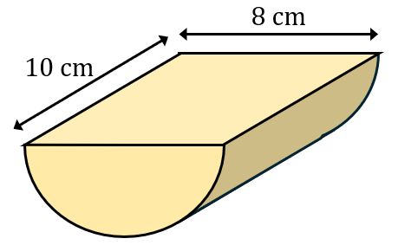 | Find the volume and surface area of the compound shape shown.  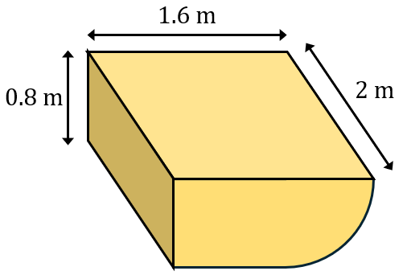
(e) | (f)
The volume of the compound shape is $630 {cm}^{3}$. Find the missing length $x$ and the total surface area of the shape.  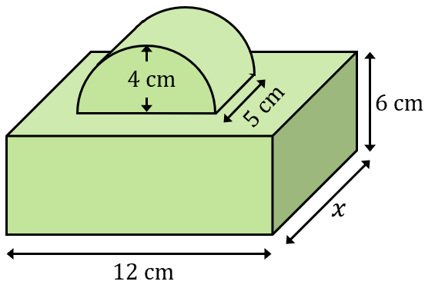 | A quarter cylinder is cut from a cuboid. The volume of the resulting shape is $292 {cm}^{3}$. Find the radius $r$ and the total surface area of the shape.  