Fill In The Blanks…
More Tree Diagrams for Independent Events

Question | Tree Diagram | Probability
Two students, Maria and Maysoon each sit their driving theory exam. Complete the tree diagram and calculate the probability of each outcome. | 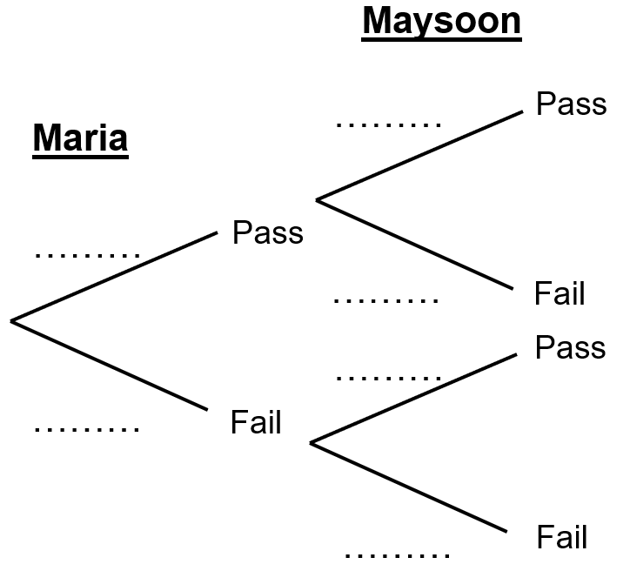 | $$P\left(PP\right)= × =$$
 |  | $$P\left(PF\right)= × =$$
 |  | $$P\left(FP\right)= × =$$
 |  | $$P\left(FF\right)=0.6×0.6=$$ | $$0.36$$
A biased coin is tossed once and then tossed again for a second time. Complete the tree diagram and calculate the probability of each outcome. | 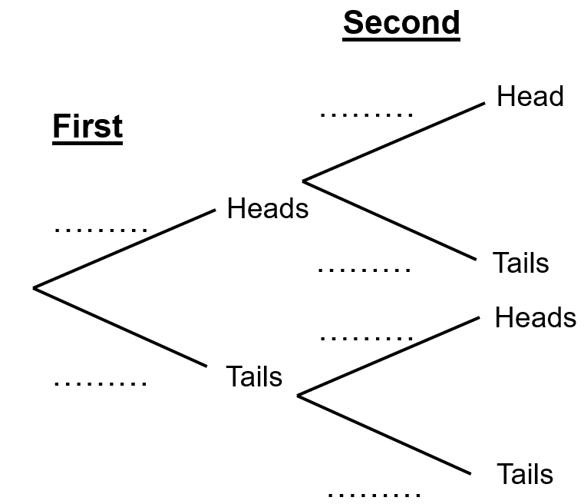 | $$P\left(HH\right)=0.2× =$$ | $$0.04$$
 |  | $$P\left(HT\right)= × =$$
 |  | $$P\left(TH\right)= × =$$
 |  | $$P\left(TT\right)= × =$$
A car travels through two sets of traffic lights. The probability of stopping at each set is the same. Complete the tree diagram and calculate the probability of each outcome. |  | $$P\left(SS\right)= × =$$
 |  | $$P\left(SG\right)= \frac{3}{7} × =$$
 |  | $$P\left(GS\right)= × =$$
 |  | $$P\left(GG\right)= × =$$
There are 12 red or blue balls in a box. There are more blue balls than red balls. A ball is removed at random, the colour recorded, then replaced. A second ball is then removed. Complete the tree diagram and probabilities. |  | $$P\left(RR\right)= × =$$
 |  | $$P\left(RB\right)= × =$$ | $$\frac{35}{144}$$
 |  | $$P\left(BR\right)= × =$$
 |  | $$P\left(BB\right)= × =$$

