Reflections Using Matrices
(a) | (b) | (c)
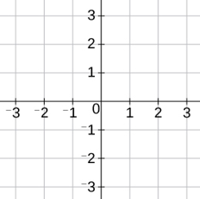  By considering the unit square, determine the matrix which describes a reflection in the $x$-axis. | Describe fully the single transformation represented by the matrix $\left(\begin{matrix}0 & 1 \\ 1 & 0\end{matrix}\right)$ | By considering the unit square, determine the matrix which describes a reflection in the line $y=-x$.
(d) | (e) | (f)
The point $(-4, 2)$ is mapped onto the point $(a, b)$ when reflected in the $x$-axis. Using matrix algebra, find the coordinates $(a, b)$. | The point $(c, d)$ is mapped onto the point $(7, -5)$ when reflected in the line $y=-x$. Using matrix algebra, find the coordinates $(c, d)$. | A triangle with vertices at $(0, 5)$, $(4, 3)$ and $(1, -1)$ is reflected in the line $y=x$. Use matrix algebra to find the coordinates of the vertices of the reflected triangle.
(g) | (h) | (i)
A triangle with vertices at $(0, 1)$, $(1, 0)$ and $(3, 2)$ is reflected so its vertices map to $(0,-1)$, $(-1, 0)$ and $(-2,-3)$. Find the transformation matrix and the line of reflection. | The point $(-2, a)$ is mapped onto the point $(b, 3)$ following a reflection in the line $x=0$. Use matrix algebra to find the values of $a$ and $b$. | The point $(x, 3x-7)$ is mapped onto the point $(y+3, y)$ following a reflection in the line $y$-axis. Use matrix algebra to find the values of $x$ and $y$.

