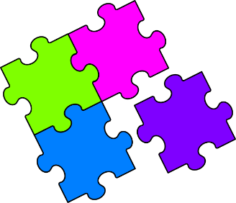
Match-Up
Equivalent Metric Lengths

1 | $$6.3 km$$ |  | 6 | $$63 m$$ |  | 11 | $$700 cm$$ |  | 16 | $$1250 m$$
2 | $$6.3 m$$ |  | 7 | $$63 km$$ |  | 12 | $$0.7 km$$ |  | 17 | $$125 m$$
3 | $$6.3 mm$$ |  | 8 | $$7 km$$ |  | 13 | $$7 cm$$ |  | 18 | $$125 cm$$
4 | $$630 m$$ |  | 9 | $$700 mm$$ |  | 14 | $$70 m$$ |  | 19 | $$125 mm$$
5 | $$6.3 cm$$ |  | 10 | $$7 mm$$ |  | 15 | $$12.5 km$$ |  | 20 | $$12.5 m$$
A | $$0.63 km$$ |  | F | $$7000 m$$ |  | K | $$6300 cm$$ |  | Q | $$1.25 km$$
B | $$70 cm$$ |  | G | $$12500 cm$$ |  | L | $$7 m$$ |  | R | $$0.63 cm$$
C | $$0.125 km$$ |  | H | $$6300 m$$ |  | M | $$7000 cm$$ |  | S | $$700 m$$
D | $$630 cm$$ |  | I | $$1.25 m$$ |  | N | $$63 mm$$ |  | T | $$12.5 cm$$
E | $$70 mm$$ |  | J | $$0.7 cm$$ |  | P | $$12500 m$$ |  | U | $$63000 m$$

1 | 2 | 3 | 4 | 5 | 6 | 7 | 8 | 9 | 10
11 | 12 | 13 | 14 | 15 | 16 | 17 | 18 | 19 | 20

