Multiplying Vectors
(a) | (b) | (c) |  | (d)
The vector $a$ is shown. Draw the vector $2a$.  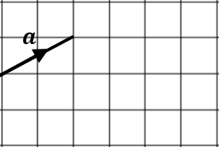 | The vector $b$ is shown. Draw the vector $3b$.  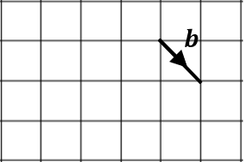 | The vector $c$ is shown. Draw the vector $-c$.  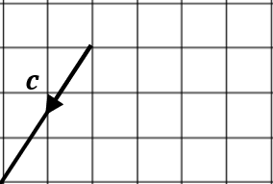 |  | The vector $d$ is shown. Draw the vector $-2d$.  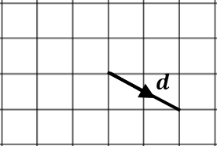
(e) | (f) | (g)
The vector $3e$ is shown. Draw the vector $2e$.  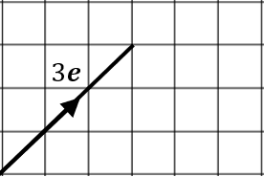 | The vector $2f$ is shown. Draw the vector $-f$.  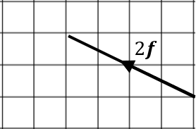 | 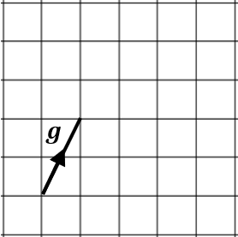 | $$g=\left(\begin{matrix}1 \\ 2\end{matrix}\right)$$  Draw and write down the column vector for  (i) $2g$ (ii) $-g$ (iii) $-3g$
(i) | (j) | (k) |  | (l)
$$a=\left(\begin{matrix}-2 \\ 5\end{matrix}\right)$$  Find $4a$ | $$b=\left(\begin{matrix}6 \\ -3\end{matrix}\right)$$  Find $-2b$ | $$c=\left(\begin{matrix}-3 \\ -12\end{matrix}\right)$$  Find $\frac{2}{3}c$ |  | $$-3d=\left(\begin{matrix}3\sqrt{2} \\ -6\end{matrix}\right)$$  Find $d$

