Origami Heart
To make this heart you will need a 15 cm square of origami paper.
Step 1 – Fold the square in half horizontally. | Step 2 – Open the paper back up. | Step 3 – Rotate through 90º and fold the square in half horizontally.
Step 4 – Open back up, then fold the bottom edge into the middle fold.  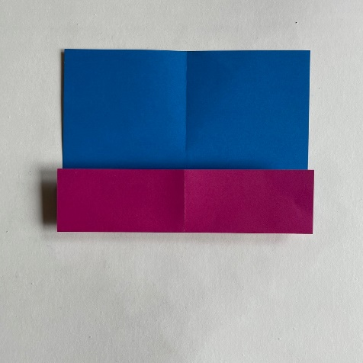 | Step 5 – Fold the top edge down to meet the middle fold.  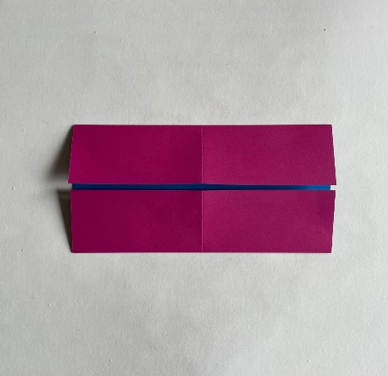 | Step 6 – Fold the top right corner down to the middle of the bottom edge.  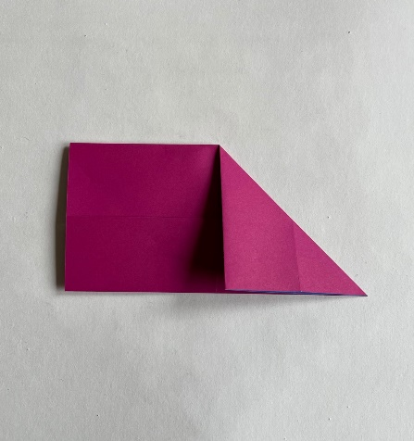
Step 7 – Repeat on the left-hand side.  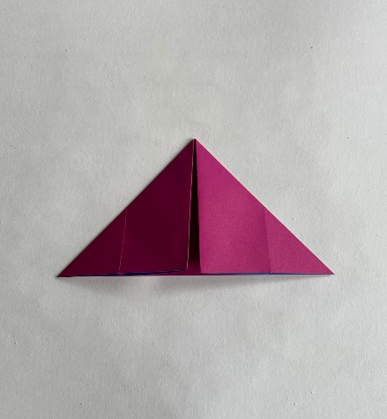 | Step 8 – Open back up, then fold the bottom right corner up to the middle of the top edge.  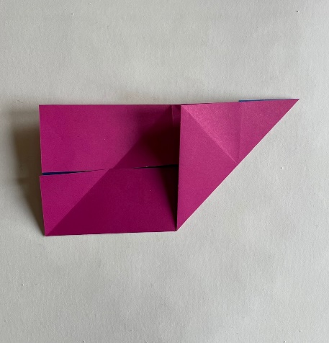 | Step 9 – Repeat on the left-hand side.
Step 10 – Open back out to show two cross-shaped folds.  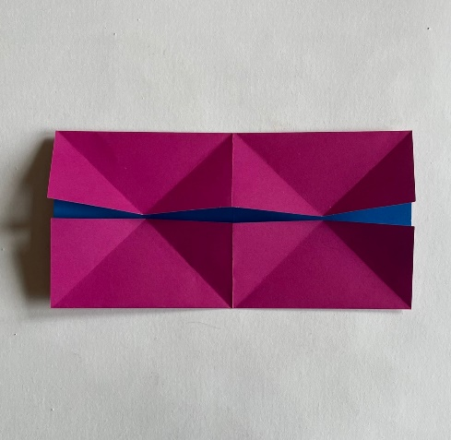 | Step 11 – Fold the right-hand edge in to meet the centre of the cross folds.  Repeat on the left-hand side.  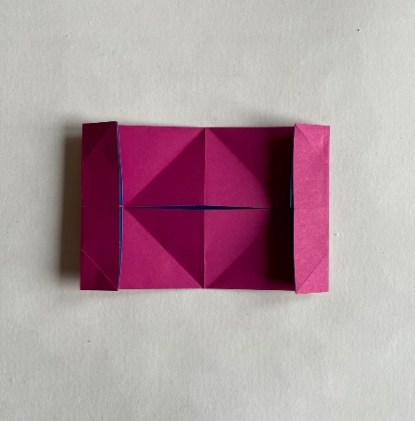 | Step 12 – Open back out to reveal two vertical folds.  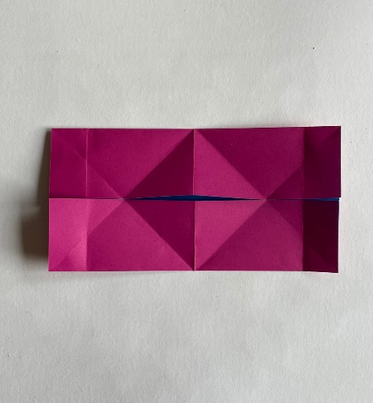
Step 13 – Fold in each corner to meet the left and right vertical folds.  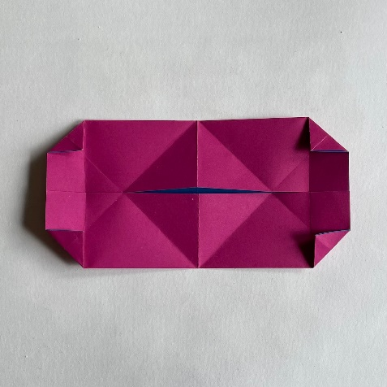 | Step 14 – Fold in half horizontally and nip the left and right edges together. | Step 15 – Push the left and right edges together to meet in the middle.
Step 16 – Push the two bottom points together and flatten. | Step 17 – Fold the top left and right corners down to meet the horizontal line. Open back up and tuck inside the heart. | Step 18 - You now have a lovely origami heart!

