Fill In The Blanks…
Pie Charts
Each pie chart shows the favourite fruit of a group of students.
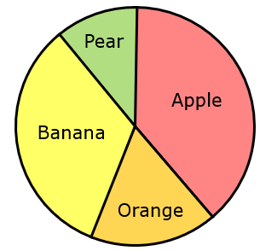 |  | Apple | Banana | Orange | Pear | Total
 | Frequency | $$7$$ | $$3$$ | $$6$$ | $$2$$ | $$18$$
 | Angle | $$140°$$ |  |  | $$40°$$ | $$360°$$
 | Proportion |  | $$\frac{1}{6}$$ | $$\frac{1}{3}$$ |  | $$1$$

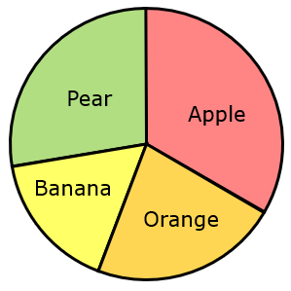 |  | Apple | Banana | Orange | Pear | Total
 | Frequency | $$12$$ |  |  |  | $$36$$
 | Angle | $$120°$$ | $$80°$$ | $$60°$$ | $$100°$$ | $$360°$$
 | Proportion | $$\frac{1}{3}$$ |  |  |  | $$1$$

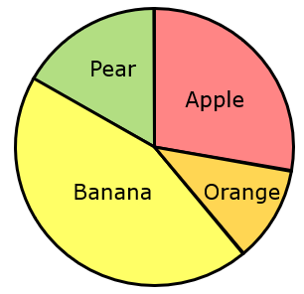 |  | Apple | Banana | Orange | Pear | Total
 | Frequency |  |  |  | $$15$$ | $$90$$
 | Angle | $$100°$$ |  | $$160°$$ |  | $$360°$$
 | Proportion |  | $$\frac{1}{9}$$ |  |  | $$1$$

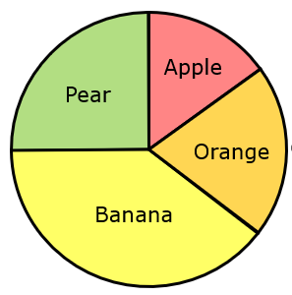 |  | Apple | Banana | Orange | Pear | Total
 | Frequency |  |  | $$24$$
 | Angle | $$54°$$ |  | $$144°$$ |  | $$360°$$
 | Proportion |  | $$\frac{1}{5}$$ |  |  | $$1$$

Fill In The Blanks…
More Pie Charts
Each pie chart shows the favourite colour of a group of students.

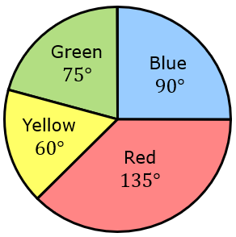 |  | Blue | Red | Yellow | Green | Total
 | Frequency |  |  |  |  | $$24$$
 | Angle |  |  |  |  | $$360°$$
 | Proportion |  |  |  |  | $$1$$

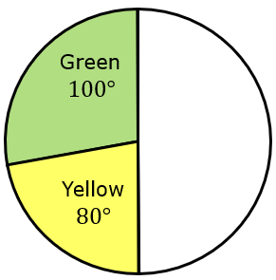 |  | Blue | Red | Yellow | Green | Total
 | Frequency | $$6$$ |  |  | $$10$$
 | Angle |  |  |  |  | $$360°$$
 | Proportion |  |  |  |  | $$1$$

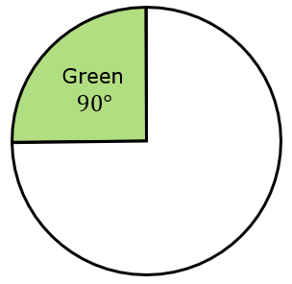 |  | Blue | Red | Yellow | Green | Total
 | Frequency |  |  |  | $$18$$
 | Angle |  |  |  |  | $$360°$$
 | Proportion | $$\frac{1}{6}$$ | $$\frac{3}{8}$$ |  |  | $$1$$

 |  | Blue | Red | Yellow | Green | Total
 | Frequency |  |  |  | $$20$$
 | Angle |  |  |  |  | $$360°$$
 | Proportion | $$\frac{2}{5}$$ |  | $$\frac{1}{4}$$ | $$\frac{1}{5}$$ | $$1$$

