Investigating Solutions to Simultaneous Equations
(a) | (b) | (c)
On the grid, plot the lines with equations  $$x+y=6$$  $$x+2y=8$$  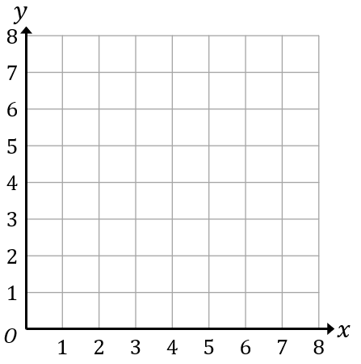  Hence find the number of solutions to the simultaneous equations  $$x+y=6$$  $$x+2y=8$$ | On the grid, plot the lines with equations  $$x+y=6$$  $$x+y=8$$  Hence find the number of solutions to the simultaneous equations  $$x+y=6$$  $$x+y=8$$ | On the grid, plot the lines with equations  $$x+y=6$$  $$2x+2y=12$$  Hence find the number of solutions to the simultaneous equations  $$x+y=6$$  $$2x+2y=12$$

