Statistics and Probability Revision |  |  | 6
(a) |  | (b)
Complete the Venn diagram to show the number of elements in each set, given the information below. |  | There are 12 pens in a pencil case. 6 pens are red, 2 are black and the rest are green. Dottie chooses two pens from the pencil case at random. Work out the probability that both the pens chosen are the same colour.
$$n\left(A∩B∩C\right)=9$$  $$n\left(A∩B\right)=11$$  $$n\left(B∩C∩A^{'}\right)=12$$  $$n{\left(A∪B∪C\right)}^{'}=7$$  $$n\left(A\right)=35$$  $$n\left(A∪B\right)=50$$  $$n\left(A∩C∩B^{'}\right)=∅$$  $$n\left(ξ\right)=75$$ | 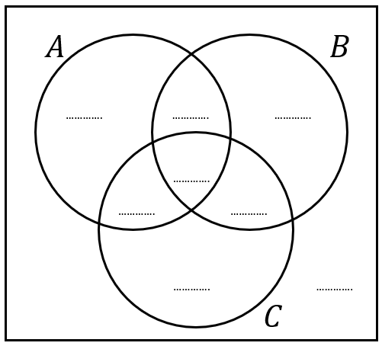
(c) |  | (d)
The histogram shows information on the distance in km that some workers commute to work each morning. Estimate the proportion of workers who commute more than 10 km.  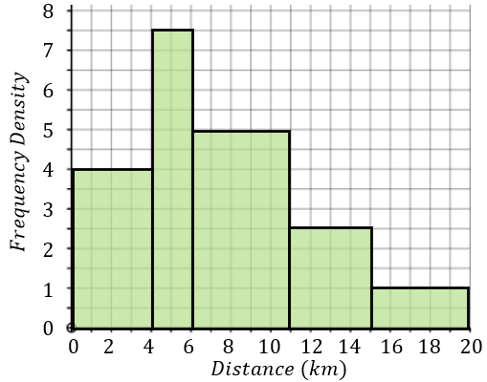 |  | A biscuit tin contains 8 bourbons and some digestives. There are $n$ biscuits in total in the tin. Roy chooses two biscuits at random from the tin. Given that the probability that Roy chooses two different types of biscuit is $\frac{48}{95}$, find the total number of biscuits in the tin.

