Fill in the Blanks | Inverse Three-Step Functions

Question | Function Machines |  |  |  |  | Answer
$$f\left(x\right)=\frac{2x+3}{5}$$  Find $f^{-1}(x)$ | 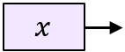 | 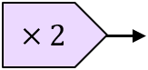 | 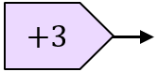 | 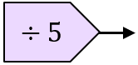 | 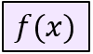 | $${ f}^{-1}\left(x\right)=$$
 | 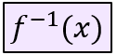 | 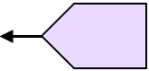 |  | 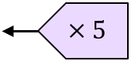 | 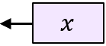
$$f\left(x\right)={4x}^{2}-5$$  Find $f^{-1}(x)$ |  | 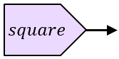 | 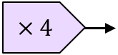 | 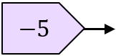 |  | $${ f}^{-1}\left(x\right)=$$
 |  | 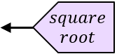 |  | 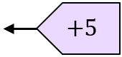
$$f\left(x\right)=2\sqrt{x}+1$$  Find $f^{-1}(x)$ |  | 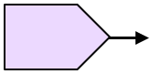 |  |  |  | $${ f}^{-1}\left(x\right)=$$
$$f\left(x\right)={\left(\frac{x-3}{2}\right)}^{2}$$  Find $f^{-1}(x)$ |  |  |  |  |  | $${ f}^{-1}\left(x\right)=$$
$$g\left(x\right)=\frac{4}{x}-3$$  Find $g^{-1}(x)$ |  |  |  |  | 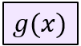 | $${ g}^{-1}\left(x\right)=$$
 | 