Fill in the Blanks | Solving Trigonometric Equations with Multiple Angles

Question | Substitute $x=…$ | Rearrange Equation | Acute Angle | Range for $x$ | Unit Circle | Solutions for $x$ | Solutions for $θ$
Solve  $$7\cos{(2θ)}=5$$  for  $$0°≤θ<180°$$ | $$x=2θ$$  $$7\cos{x}=5$$ | $$\cos{x}=\frac{5}{7}$$ | $$x=\cos^{-1}\left(\frac{5}{7}\right)$$  $$x=44.415°$$ | $$0°≤x<360°$$ | 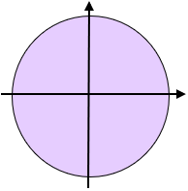
Solve  $$8\sin{(3θ)}-7=0$$  for  $$-90°≤θ<90°$$ | $$x=3θ$$  $$8\sin{x}-7=0$$
Solve
$$\frac{4}{\tan\left(θ+25\right)}=3$$
for
$$-180°≤θ<180°$$
$$9\cos\left(2θ-15\right)=4$$
for
$$0°≤θ<360°$$
$$\frac{\tan\left(3θ+70\right)}{2}+3=0$$
for
$$-90°≤θ<90°$$

