Match-Up | Arc Length and Perimeter in Radians

1 | Find the arc length in $cm$ of a sector with radius $15 cm$ and angle $1.3$ radians. | 2 | Find the arc length in $cm$ of a sector with radius $8 cm$ and angle $\frac{7π}{4}$ radians. | A | $$1.6$$
 |  |  |  | B | $$2.2$$
3 | Find the radius in cm.  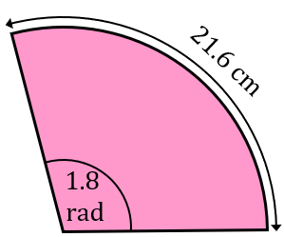 | 4 | Find the angle in radians subtended by an arc of length $12 cm$ when the radius is $7.5 cm$. | C | $$5π+16$$
 |  |  |  | D | $$\frac{3π}{5}$$
5 | Find the perimeter in $cm$ of a sector with an angle of $0.85$radians and a radius of $8 cm$. | 6 | A sector has a perimeter of $44.1 cm.$ Given that its radius is $10.5 cm$, find the angle in radians. | E | $$19.5$$
 |  |  |  | F | $$0.9$$
7 | The perimeter of a sector with radius $12 cm$ is the same as the perimeter of a square with area $100 {cm}^{2}$. Find the angle of the sector in radians. | 8 | Find the perimeter in $cm$ of a sector with a radius of $8 cm$and an angle of $\frac{5π}{8}$ radians. | G | $$12$$
 |  |  |  | H | $$14π$$
9 | The perimeter of a sector is $\left(9π+30\right) cm$. If the radius is $15 cm$, find the angle in radians. | 10 | The perimeter of a rectangle of length $8 cm$ and width $6.5 cm$ is half the perimeter of a sector with radius $20 cm$. Find the angle of the sector in radians. | I | $$\frac{55π}{6}+16$$
 |  |  |  | J | $$11$$
11 | The perimeter of a sector is $35.75 cm$. If the angle at the centre of the sector is $1.25$ radians, find its radius in $cm$. | 12 | Find the perimeter of the shaded shape in $cm$.  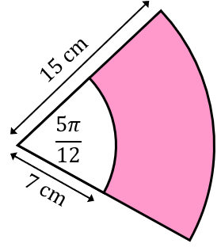 | K | $$\frac{4}{3}$$
 |  |  |  | L | $$22.8$$

1 | 2 | 3 | 4 | 5 | 6 | 7 | 8 | 9 | 10 | 11 | 12

