Sporting Speeds
Sport |  | Distance | Time | Speed (km/h) | Speed (m/s)
Adam Peaty Swimming |  | $$100 m$$ | $$56.88 seconds$$ | $$6.33 km/h$$
Battaash  Horse Racing |  | $$1 km$$ | $$50.9 seconds$$
Mark Cavendish  Cycling | 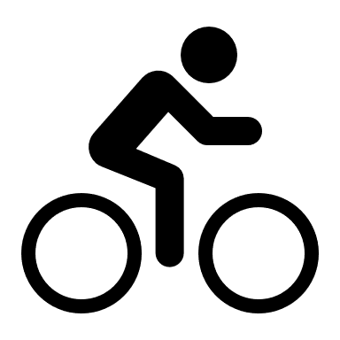 | $$200 m$$ |  |  | $$21.7 m/s$$
Rafael Nadal’s  Tennis Ball |  |  | $$0.47 seconds$$ |  | $$50 m/s$$
Usain Bolt  100 m Sprint |  | $$100 m$$ | $$9.58 seconds$$
Max Verstappen  Formula 1 |  |  | $$1 minute$$  $$14 seconds$$ | $$157.8 km/h$$
Lionel Messi’s  Football |  | $$23.4 m$$ |  | $$130 km/h$$
Mo Farah  Marathon |  | $$42.24 km$$ | $$2 hours 10 min$$  $$28 seconds$$

