Graphs of Hyperbolic Functions
$$y=\cosh{x}$$ | $$y=\sinh{x}$$ | $$y=\tanh{x}$$
$$\cosh{x}=\frac{e^{x}+e^{-x}}{2}$$ | $$\sinh{x}=\frac{e^{x}-e^{-x}}{2}$$ | $$\tanh{x}=\frac{e^{2x}-1}{e^{2x}+1}$$
The graph of $y=\cosh{x}$ is the mean of the graphs $y=e^{x}$ and $y=e^{-x}$.  Plot the graph on the grid below. | The graph of $y=\sinh{x}$ is the mean of the graphs $y=e^{x}$ and $y=-e^{-x}$.  Plot the graph on the grid below.
  $$x$$ | $$-3$$ | $$-2$$ | $$-1$$ | $$0$$ | $$1$$ | $$2$$ | $$3$$
  $$y$$
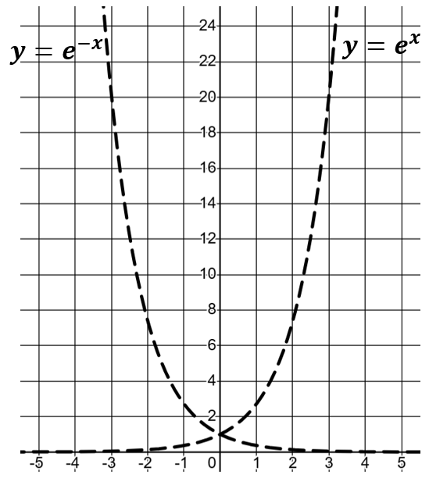 | 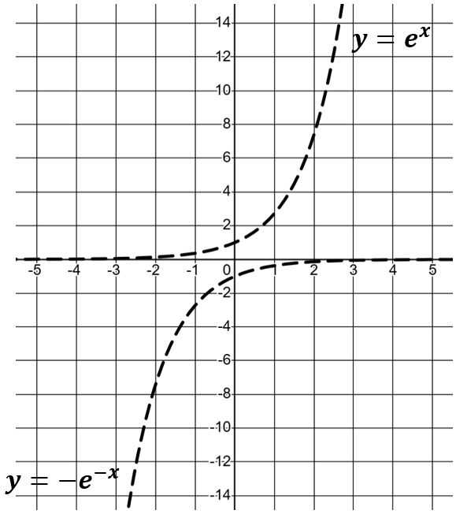 | Complete the table and plot the graph.  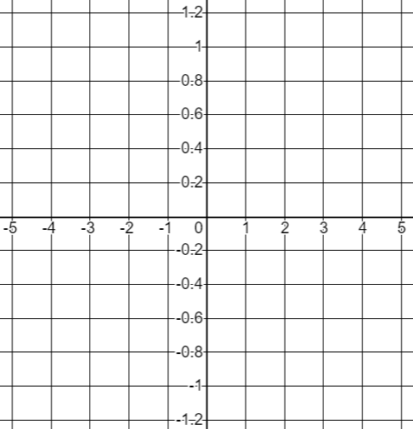
What similarities are there between the graph of $y=\cosh{x}$ and $y=\cos{x}$? | What similarities are there between the graph of $y=\sinh{x}$ and $y=\sin{x}?$ | What similarities are there between the graph of $y=\tanh{x}$ and $y=\tan{x}$?

