Fill In The Blanks…
Multiplying Algebraic Fractions

Question | Write as a Single Fraction | Simplify Numerator and Denominator | Simplified Answer  (where possible)
$$\frac{x}{4}×\frac{2x}{3}$$ | $$\frac{x×2x}{4×3}$$ | $$\frac{2x^{2}}{12}$$ | $$\frac{x^{2}}{6}$$
$$\frac{x}{6}×\frac{4y}{5}$$ | $$\frac{x×4y}{6×5}$$ | $$\frac{4xy}{30}$$
$$\frac{2}{x}×\frac{3xy}{5}$$ | $$\frac{2×3xy}{x×5}$$
$$\frac{4x}{3y}×\frac{2y}{x}$$
$$\frac{2}{7x}×\frac{3xy}{4}$$
$$\frac{x^{2}}{8}×\frac{4y}{x}$$
$$\frac{2y}{x}×\frac{9x^{2}y}{4}$$
$$\frac{10y}{x^{2}}×\frac{3xy^{2}}{5}$$
$$\frac{4yz}{3}×\frac{x^{2}}{6y^{3}}$$
$$\frac{2x^{3}}{15yz}×\frac{5x^{2}y^{2}}{z^{3}}$$
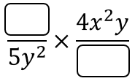 | 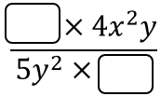 | $$\frac{24x^{3}y}{15y^{2}}$$
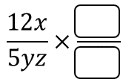 |  |  | $$\frac{{6x}^{3}y}{25z}$$

