Crack the Code
Trigonometry

A | 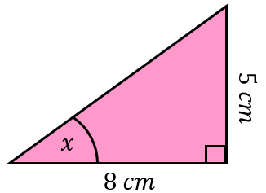 | B | 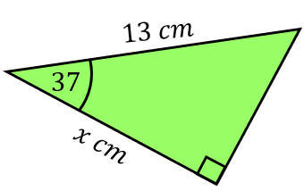 | C | 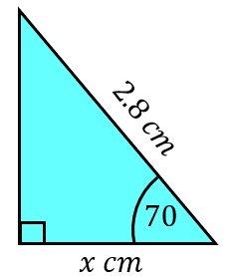
D | 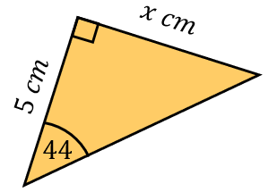 | E | 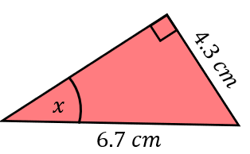 | F | 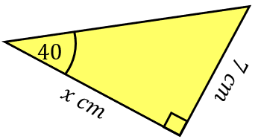
G | 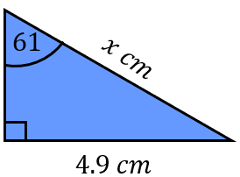 | H | 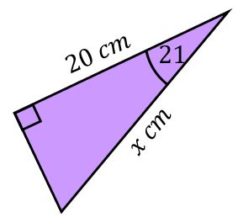 | I | 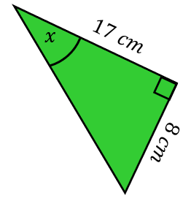
J | 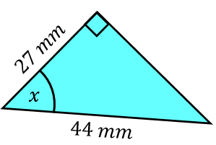 | K | 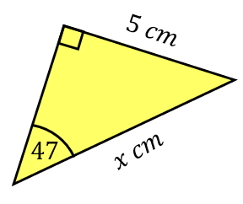 | L | 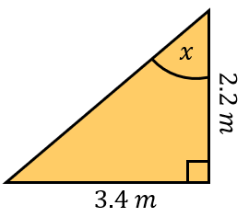
M | 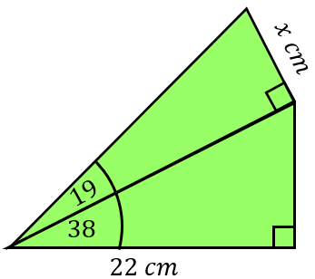 | N | 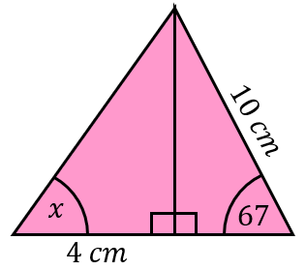 | O | 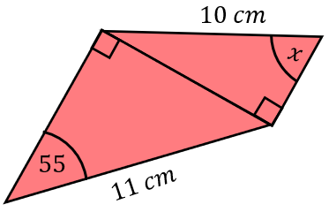
Round each of your answers to 1 decimal place. To get the three-digit code, add together all your answers and round to the nearest integer.

