Shading Regions with Quadratic Inequalities
Shade the region or regions which satisfy the inequalities given.
(a) | (b) | (c)
$y>x^{2}-2x-3$  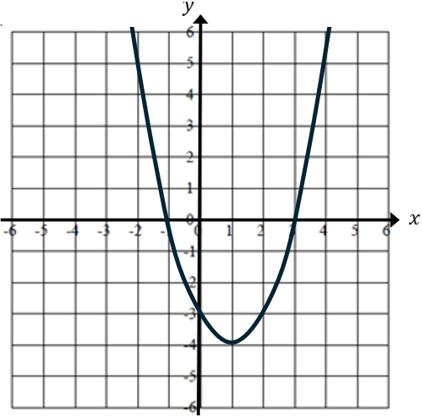 | $y≤4+3x-x^{2}$ and $y>x+1$  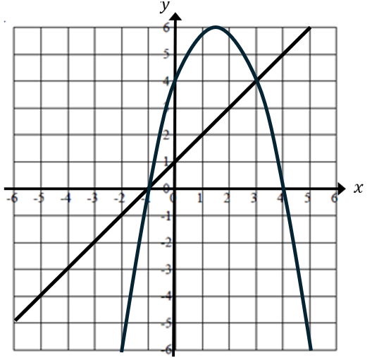 | $y≥x^{2}-4x$ and $y<5-x$  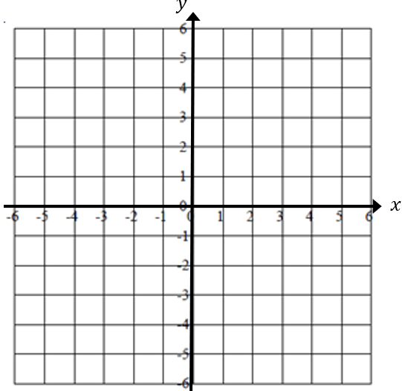
(d) | (e) | (f)
$y>x^{2}-1$ and $y≤6-x-x^{2}$ | $y>\frac{1}{2}x^{2}-2, y≤x+4$ and $y<5$ | $y<4-3x-x^{2}, 2x+y+4>0$ ,  $x≤0$ and $y>-2$

