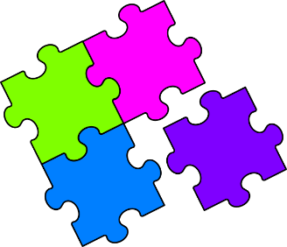Match-Up

**Histograms**

|  |  |  |  |  |  |  |  |
| --- | --- | --- | --- | --- | --- | --- | --- |
| **1** | | **2** | | **3** | | **4** | |
|  | |  | |  | |  | |
| **5** | | **6** | | **7** | | **8** | |
|  | |  | |  | |  | |
|  |  |  |  |  |  |  |  |
| **A** | | **B** | | **C** | | **D** | |
| |  |  | | --- | --- | | Time | Freq | |  |  | |  |  | |  |  | |  |  | | | |  |  | | --- | --- | | Time | Freq | |  |  | |  |  | |  |  | |  |  | | | |  |  | | --- | --- | | Time | Freq | |  |  | |  |  | |  |  | |  |  | | | |  |  | | --- | --- | | Time | Freq | |  |  | |  |  | |  |  | |  |  | | |
| **E** | | **F** | | **G** | | **H** | |
| |  |  | | --- | --- | | Time | Freq | |  |  | |  |  | |  |  | |  |  | | | |  |  | | --- | --- | | Time | Freq | |  |  | |  |  | |  |  | |  |  | | | |  |  | | --- | --- | | Time | Freq | |  |  | |  |  | |  |  | |  |  | | | |  |  | | --- | --- | | Time | Freq | |  |  | |  |  | |  |  | |  |  | | |

|  |  |  |  |  |  |  |  |
| --- | --- | --- | --- | --- | --- | --- | --- |
| **1** | **2** | **3** | **4** | **5** | **6** | **7** | **8** |
|  |  |  |  |  |  |  |  |