Sets and Venns Revision
(a) |  | (b) | (c) |  | (d)
$$ξ=\left\{1, 2, 3, 4, 5, 6, 7, 8, 9, 10\right\}$$  $$A=\{1, 2, 3, 4, 5, 6\}$$  $$B=\left\{even numbers\right\}$$  List the members of $A∩B$ |  | $$ξ=\left\{1, 2, 3, 4, 5, 6, 7, 8, 9, 10\right\}$$  $$A=\{factors of 9\}$$  $$B=\left\{multiples of 4\right\}$$  List the members of $A∪B$ | $$ξ=\left\{1, 2, 3, 4, 5, 6, 7, 8, 9, 10\right\}$$  $$A=\{factors of 9\}$$  $$B=\left\{multiples of 4\right\}$$  Anna says that $A∩B=∅.$ Is she correct? |  | $$A=\{1, 3, 5, 7, 9\}$$  $$A∩B=\left\{1, 3\right\}$$  $$A∪B=\{0, 1, 2, 3, 4, 5, 7, 9\}$$  List the members of $B$
(e) |  | (f) | (g) |  | (h)
Shade the region which represents $A∩B'$  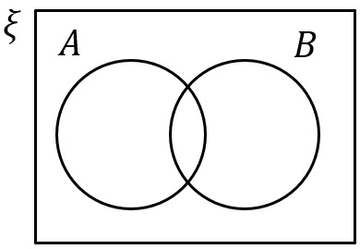 |  | Shade the region which represents $A'∪B$ | Show in a Venn diagram.  $$ξ=\left\{1, 2, 3, 4, 5, 6, 7, 8, 9, 10\right\}$$  $$A=\left\{1, 4, 9, 10\right\}$$  $$B=\left\{2, 4, 6, 8, 10\right\}$$ |  | List the members of $B'$  and $A'∩B'$  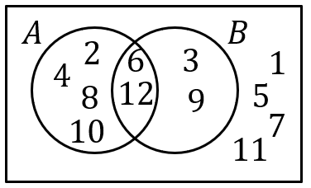
(i) |  |  | (j)
In a group of 20 students, 11 like Maths and 10 like English. 2 like neither subject.  (a) Complete the Venn diagram.  (b) How many students like Maths but not English? | 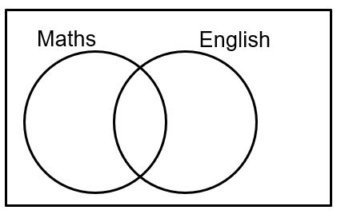 |  | There are 32 students in a class. 21 students like Spanish and 15 like Geography. There are twice as many students who like both subjects as like neither.  (a) Complete the Venn diagram.  (b) How many students like only Spanish? | 