Rotational Symmetry

Write down the order of rotational symmetry of each of these shapes.
(a) (b)

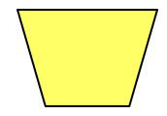
(c) (d)

Write down the order of rotational symmetry of these regular polygons.
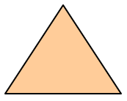
(a) (b)

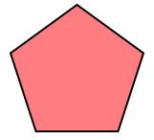
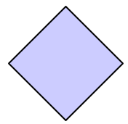
(c) (d)

Which of these shapes does not have the same number of lines of symmetry as its order of rotational symmetry?

Add one square to each shape so that is has rotational symmetry of order shown.
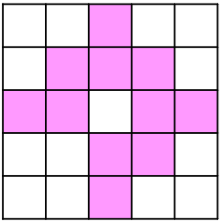
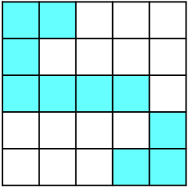
(a) Order 2 (b) Order 4

Rotational Symmetry

Write down the order of rotational symmetry of each of these shapes.
(a) (b)

(c) (d)

Write down the order of rotational symmetry of these regular polygons.
(a) (b)

(c) (d)

Which of these shapes does not have the same number of lines of symmetry as its order of rotational symmetry?

Add one square to each shape so that is has rotational symmetry of order shown.
(a) Order 2 (b) Order 4

