Fill in the Blanks | Tree Diagrams for Dependent Events

Question | Tree Diagram | Probability
There are some white counters and some red counters in a bag. Two counters are taken from the bag at random. Complete the tree diagram and calculate the missing probabilities. | 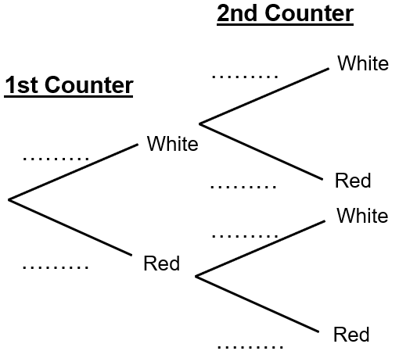 | $$P\left(WW\right)= × =$$
 |  | $$P\left(WR\right)= × =$$
 |  | $$P\left(RW\right)= × =$$
 |  | $$P\left(RR\right)= \frac{5}{8} × \frac{4}{7} =$$ | $$\frac{20}{56}$$
There are some apples and some oranges in a fruit bowl. Two pieces of fruit are chosen at random. Complete the tree diagram and calculate the missing probabilities. | 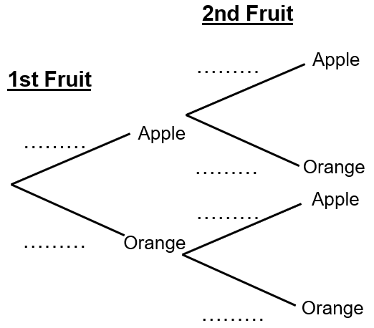 | $$P\left(AA\right)= × \frac{2}{9} =$$
 |  | $$P\left(AO\right)= × =$$
 |  | $$P\left(OA\right)= × =$$
 |  | $$P\left(OO\right)= × =$$
Milo has some black socks and some grey socks in a drawer. He chooses two socks at random. Draw a tree diagram and calculate the missing probabilities. |  | $$P\left(BB\right)= × =$$
 |  | $$P\left(BG\right)= × \frac{5}{11} =$$
 |  | $$P\left(GB\right)= × =$$
 |  | $$P\left(GG\right)= × =$$
Adrianna buys some sausage rolls and some cheese pasties from the bakery. She chooses two items at random to eat for lunch. Draw a tree diagram and calculate the missing probabilities. |  | $$P\left(SS\right)= × =$$
 |  | $$P\left(SC\right)= × =$$
 |  | $$P\left(CS\right)= × =$$
 |  | $$P\left(CC\right)= × =$$ | $$\frac{12}{110}$$

