Graphical Inequalities Worded Problems
(a) | (b) | (c)
Junior’s pencil case contains pens and pencils. The total number of pens and pencils is less than 25. The number of pens is greater than 5. The number of pencils is between 4 and 16. | A factory manufactures beds and sofas. Each week it makes at least 30 beds and between 40 and 100 sofas. The factory always manufactures more sofas than beds. | Maya is baking cakes and brownies. Each cake needs 50g of sugar and 20g of flour. Each cookie needs 30g of sugar and 50g of flour. She has 300g of sugar and 200g of flour and wants to make at least 2 cakes.
(a) By letting $x$ represent the number of pens and $y$ the number of pencils, write inequalities to represent this problem. | (a) By letting $x$ represent the number of beds and $y$ the number of sofas, write inequalities to represent this problem. | (a) By letting$x$ represent the number of cakes and $y$ the number of cookies, write inequalities to represent this problem.
(b) Represent this problem graphically, shading the region which satisfies all the inequalities.  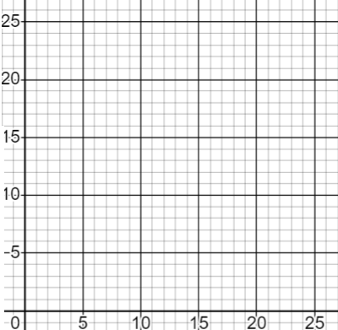 | (b) Represent this problem graphically, shading the region which satisfies all the inequalities.  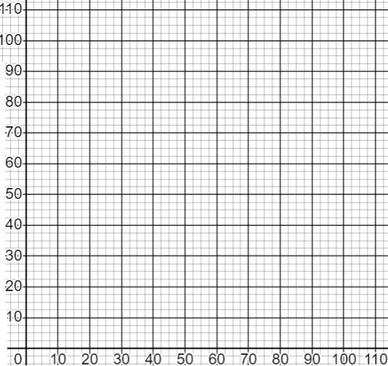 | (b) Represent this problem graphically, shading the region which satisfies all the inequalities.  