Pythagoras and Trigonometry

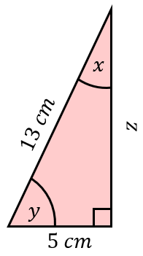
Find all the missing lengths and angles in each of these right-angled triangles, to 1 decimal place.
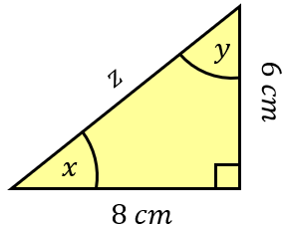
(a) (b)

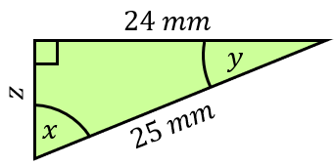
(c)

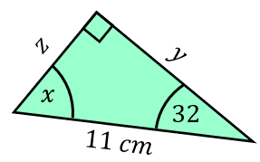
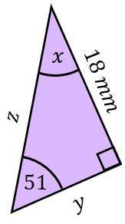
Find the values of $x$, $y$ and $z$ to 1 decimal place.
(a) (b)

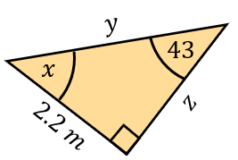
(c)

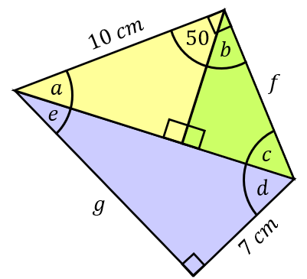
Find all the missing angles and lengths in this diagram, rounding to 1 decimal place when required.

Pythagoras and Trigonometry

Find all the missing lengths and angles in each of these right-angled triangles, to 1 decimal place.
(a) (b)

(c)

Find the values of $x$, $y$ and $z$ to 1 decimal place.
(a) (b)

(c)

Find all the missing angles and lengths in this diagram, rounding to 1 decimal place when required.

