Arc Length and Perimeter of a Sector
(a) | (b) | (c) | (d) |  | (e)
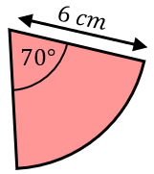  Find the arc length. | Find the arc length.  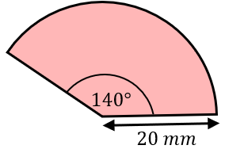 | 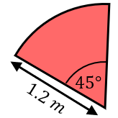  Find the arc length. | Find the arc length.  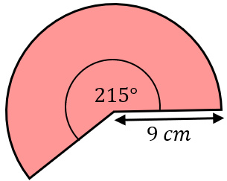 |  | Find the arc length.  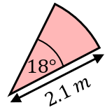
(f) | (g) | (h) | (i) |  | (j)
Find the perimeter.  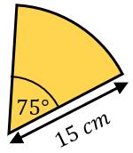 | Find the perimeter.  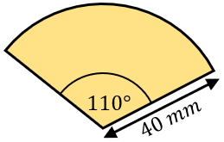 | Find the perimeter.  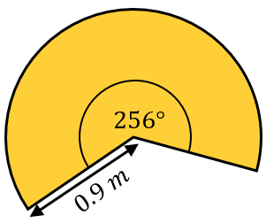 | 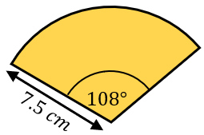  Find the perimeter. |  | 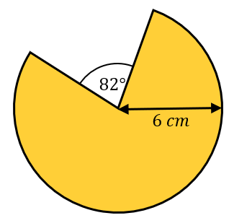  Find the perimeter.
(k) | (l) | (m) |  | (n)
Find the perimeter.  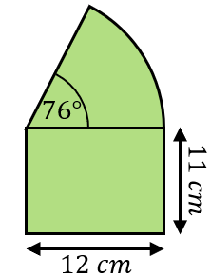 | 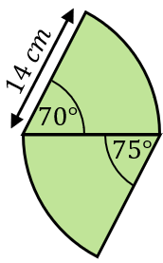  Find the perimeter. | Farmer Jo wants to put a fence around his sector-shaped field. Fencing costs £18.99 per metre. How much will it cost Farmer Jo?  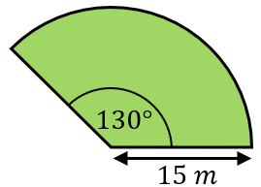 |  | The pendulum of a clock is 48 cm long and swings through an angle of $15°$. The pendulum swings back and forth every two seconds. How far does the end of the pendulum swing in a minute?

