Plotting Graphs Revision
(a) | (c) | (e)
Plot the graph of the equation $y=2x+3$  $$x$$ $$-2$$ $$-1$$ $$0$$ $$1$$ $$2$$ $$3$$  $$y$$  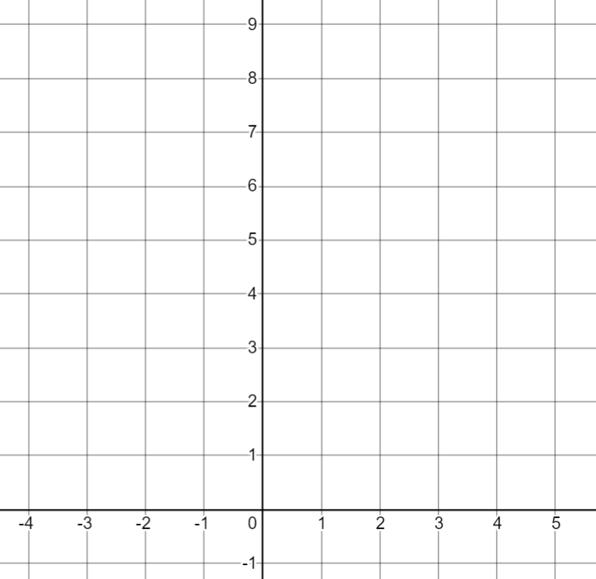 | Plot the graph of $y=x^{2}-4x+2$  $$x$$ $$-1$$ $$0$$ $$1$$ $$2$$ $$3$$ $$4$$ $$5$$  $$y$$  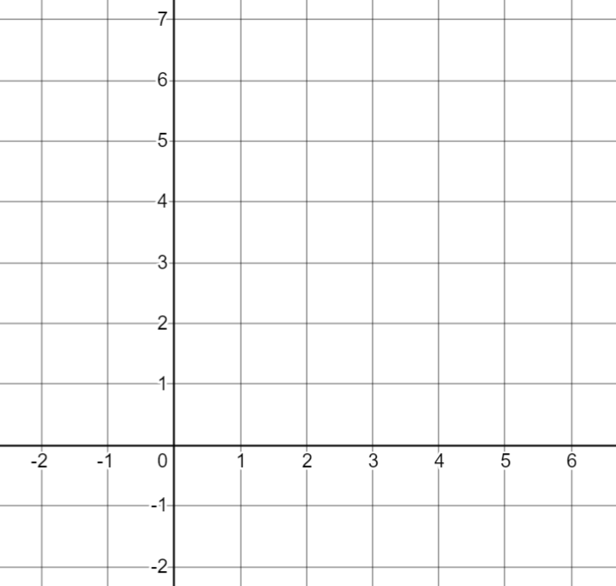 | Plot the graph of $y=x^{3}-4x^{2}+5$  $$x$$ $$-1$$ $$0$$ $$1$$ $$2$$ $$3$$ $$4$$  $$y$$  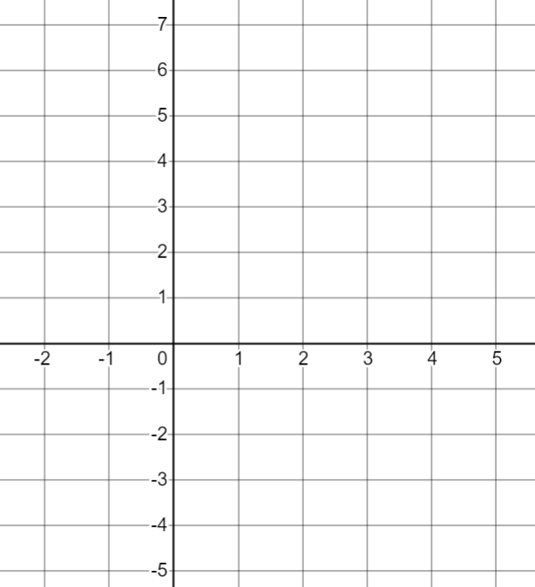
(b) | (d) | (f)
On the grid, plot the graph of $2x-3y=6$ from $x=0$to $x=9$  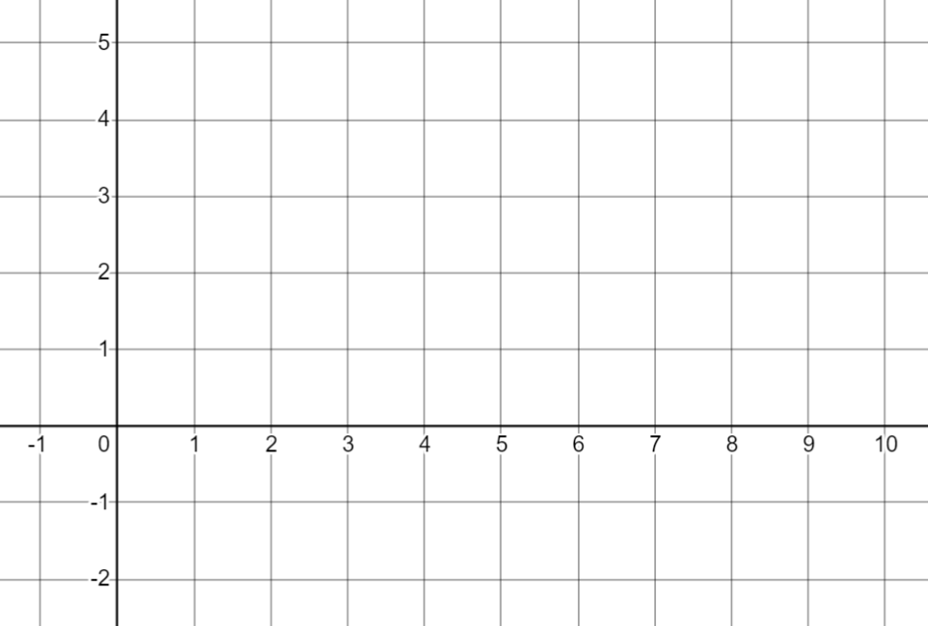 | Plot the graph of $y=2+x-x^{2}$ for $x=-3$ to $x=3$  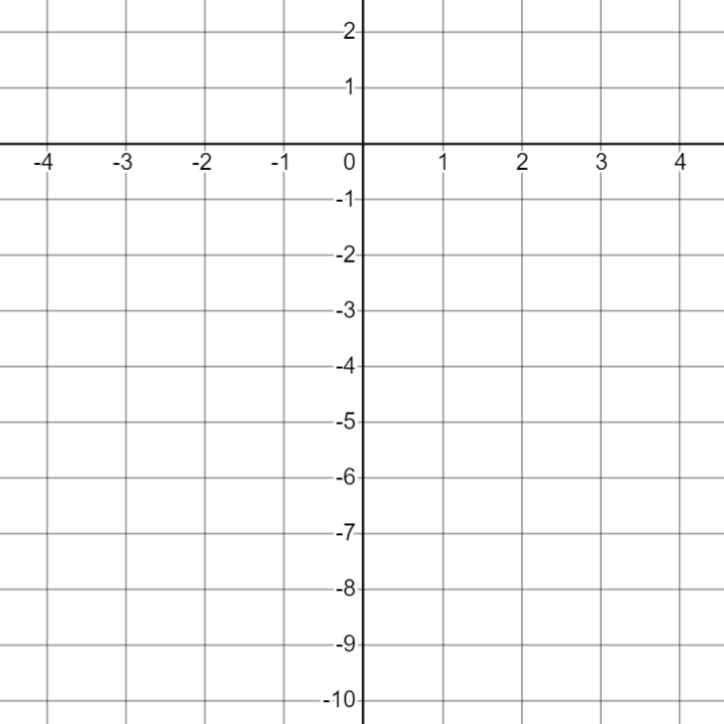 | Plot the graph of $y=x+\frac{8}{x}$  $$x$$ $$1$$ $$2$$ $$3$$ $$4$$ $$6$$ $$8$$  $$y$$

