Statistics and Probability Revision |  |  |  |  | 3
(a) |  | (b)
The frequency table shows the number of different sizes of shoes sold across a week. |  | Chloe asked a number of students to choose their favourite fruit. The pie chart (not drawn to scale) shows this information.
Shoe Size Frequency  4 3  5 11  6 8  7 5  8 9  9 4 | (i) Write down the modal shoe size.  (ii) Work out the total number of pairs of shoes sold.  (iii) Calculate the mean shoe size. | 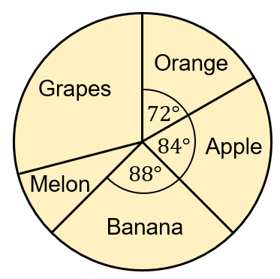 |  | (i) 18 students chose orange as their favourite fruit. How many students chose banana?  (ii) 27 students chose grapes. Work out the size of the pie chart angle for grapes.
(c) |  | (d)
The heights of 50 plants are measured and recorded in a grouped frequency table. |  | 40 children were asked whether they have a brother(B) or sister(S). Of the 40 children, 11 have both a brother and a sister, 8 have only a sister, and 15 have neither a brother or a sister.
Height $h$ (cm) | Frequency
$$20≤h<30$$ | $$11$$
$$30≤h<40$$ | $$8$$
$$40≤h<50$$ | $$23$$
$$50≤h<60$$ | $$5$$
$$60≤h<70$$ | $$3$$
(i) Write down the modal class.

(ii) Calculate an estimate for the mean height.
 |  | (i) Complete the Venn diagram.  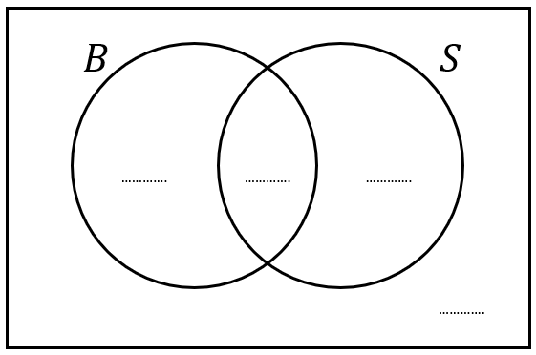 | (ii) A child is chosen at random. Find the probability that the child chosen has a brother.  (iii) Find $P(S^{'})$

