Geometry Revision |  |  |  | 3
(a) | (b) | (c) | (d)
Work out the area of the shape shown.  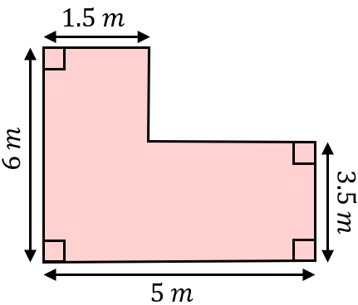 | On the grid, translate triangle A by the vector $\left(\begin{matrix}5 \\ -2\end{matrix}\right)$  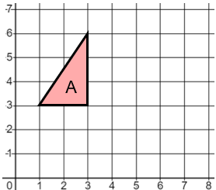 | The surface area of the cube shown is $486 {cm}^{2}$. Find the value of $x$.  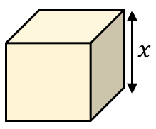 | Find the value of $x$. Give reasons for your answer.  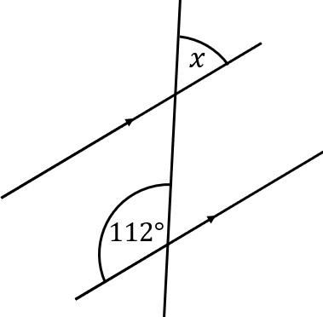
(e) | (f) | (g) | (h)
Using only ruler and compasses, construct an equilateral triangle. The first side has been drawn for you. | (i) Calculate the area of a circle with a radius of $8 cm$. Give your answer to 1 decimal place.  (ii) Calculate the circumference of a circle with a radius of  $55 mm$. Leave your answer in terms of $π$. | On the grid, reflect shape B in the line $y=4$.  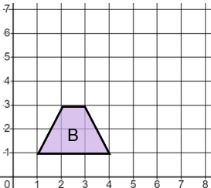 | The volume of the triangular prism shown is $1512 {cm}^{3}$. Find the value of $x$.  