Investigating Triangles Inside Circles
The first three diagrams show two joined isosceles triangles that fit together inside a semicircle. Calculate all marked angles and write down what you notice about the shaded angle. In the final diagram, choose your own angles and test your theory.
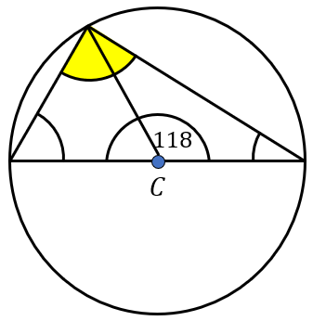 | 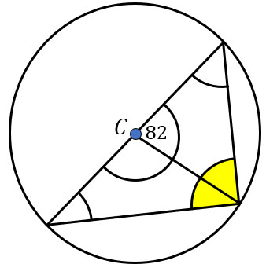 | 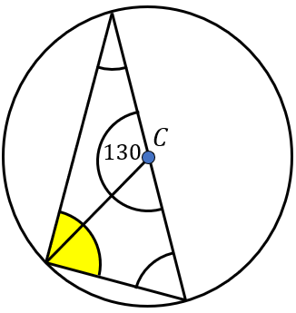 | 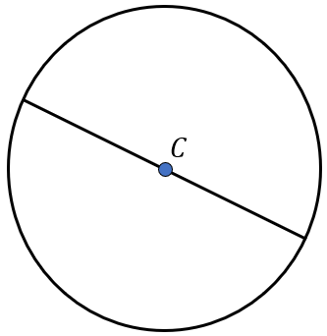
What did you notice?
The next three diagrams show two joined isosceles triangles that fit together inside a full circle. Calculate all marked angles and write down what you notice about the shaded angles. In the final diagram, choose your own angles and test your theory.
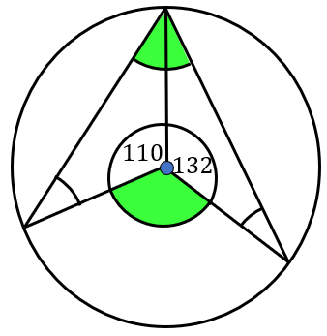 | 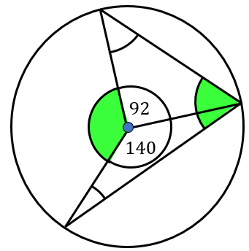 | 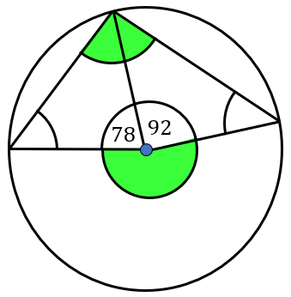
What did you notice?

