Scale Drawings
Design a Bedroom | Design a Park
Using a scale of 1 cm : 25 cm, draw the bedroom shown.  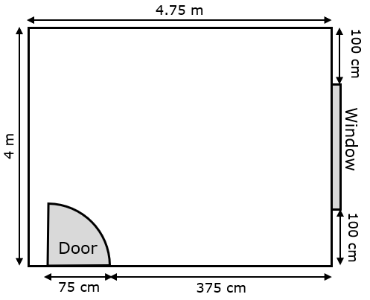  Now add the following to the bedroom:  Double Bed 150 cm by 200 cm  Wardrobe 175 cm by 75 cm  Drawers 100 cm by 50 cm  Desk 1 m by 0.5 m  Armchair 75 cm by 75 cm  Rug 1 m by 1.75 m  Bedside Table 50 cm by 50 cm | Using a scale of 1 : 1000, draw the park area shown.  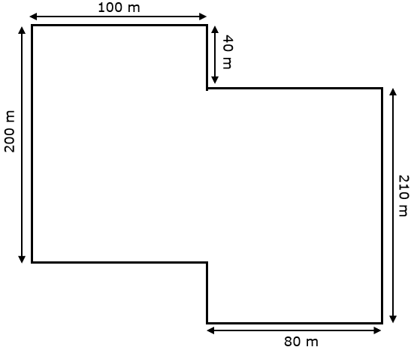  Now add the following to the park:  Football Pitch 100 m by 80 m  Tennis Court 80 m by 40 m  Picnic Area 30 m by 20 m  Play Area 60 m by 45 m  Vegetable Garden 20 m by 20 m  Two Flowerbeds 50 m by 10 m each  Duck Pond Circular – radius 25 m

