Finding the Length of a Short Side using Pythagoras’ Theorem
(a) Find $x$ to 1 decimal place |  | (b) Find $x$ |  | (c) Find $y$ to 1 decimal place
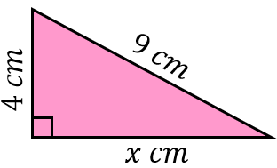 | $$9^{2}=x^{2}+4^{2}$$  $$x^{2}=9^{2}-4^{2}$$  $$x^{2}=65$$  $$x=\sqrt{65}$$  $$x=8.1 cm (1 dp)$$ | 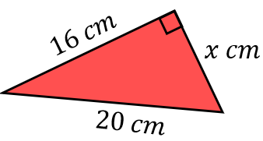 | $${20}^{2}=x^{2}+{16}^{2}$$  $$x^{2}={20}^{2}-{16}^{2}$$ | 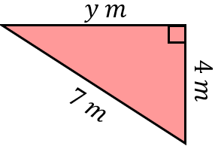 |  | $$7^{2}=y^{2}+4^{2}$$  $$y^{2}=7^{2}-4^{2}$$
(d) Find $x$ |  | (e) Find $y$ to 1 decimal place |  | (f) Find $x$ to 1 decimal place
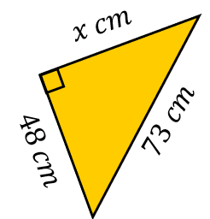 |  | 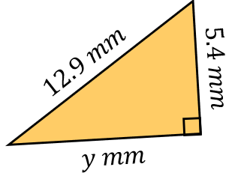 |  | 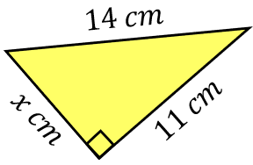
(g) Find$x$ to 1 decimal place |  | (h) Find $y$ |  | (i) Find $y$ to 1 decimal place
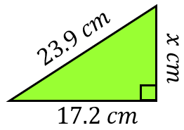 |  | 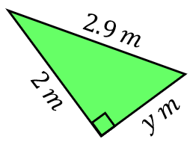 |  | 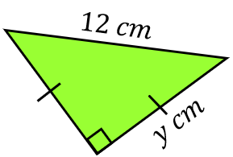
(j) Find $x$, leaving your answer as a surd |  | (k) Find $y$, leaving your answer as a surd |  | (l) Find $x$, leaving your answer as a surd
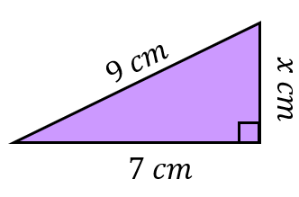 |  | 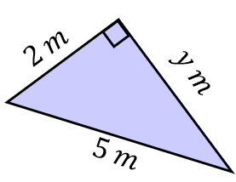 |  | 