Volume and Surface Area of Cones

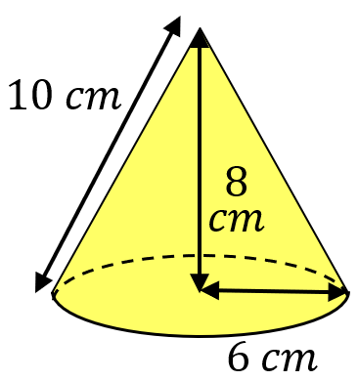
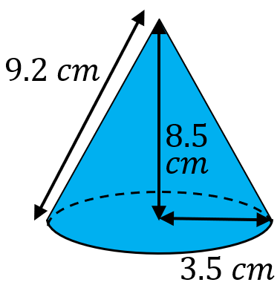
Find the volume and total surface area of each of these cones.
(a) (b)

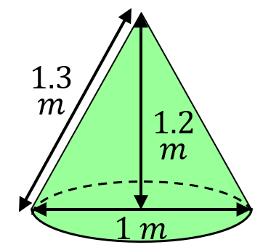
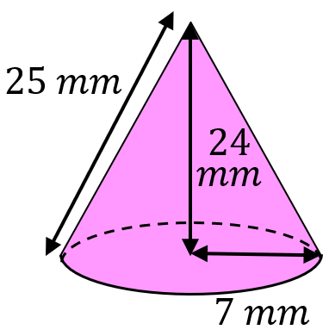
(c) (d)

Find the slanted height and curved surface area of these cones.
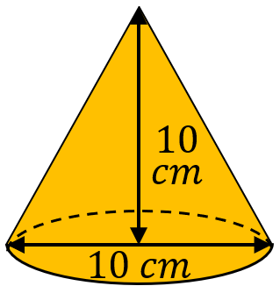
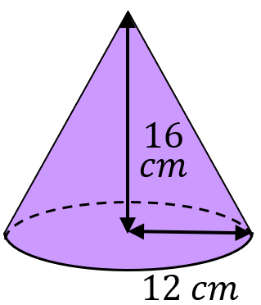
(a) (b)

Find the missing lengths.
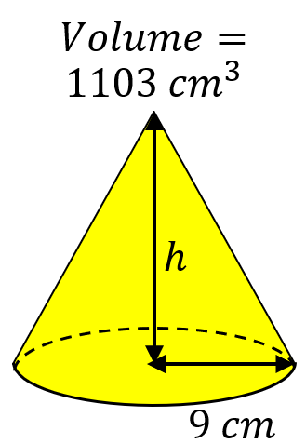
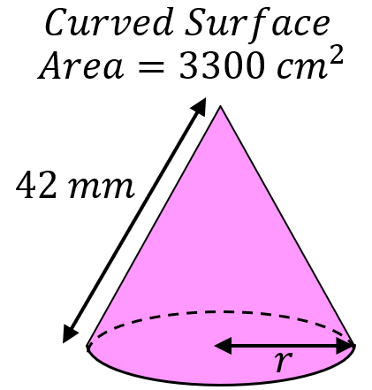
(a) (b)

(a) A cone has a slanted height of $26 cm$ and a curved surface area of $260π {cm}^{2}$. Find its volume.
(b) A cone has a radius of $8.5 cm$ and a volume of $1059 {cm}^{3}$. Find its total surface area.
Volume and Surface Area of Cones

Find the volume and total surface area of each of these cones.
(a) (b)

(c) (d)

Find the slanted height and curved surface area of these cones.
(a) (b)

Find the missing lengths.
(a) (b)

(a) A cone has a slanted height of $26 cm$ and a curved surface area of $260π {cm}^{2}$. Find its volume.
(b) A cone has a radius of $8.5 cm$ and a volume of $1059 {cm}^{3}$. Find its total surface area.

