Surface Area of Cubes and Cuboids

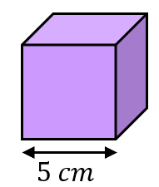
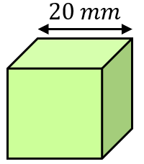
Find the surface area of each of these cubes.
(a) (b)

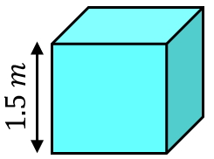
(c)

Find the surface area of each of these cuboids.
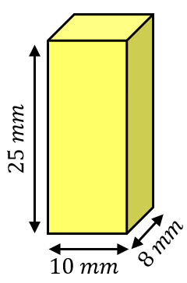
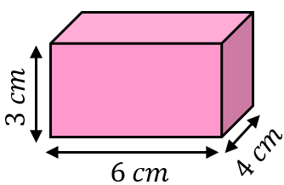
(a) (b)

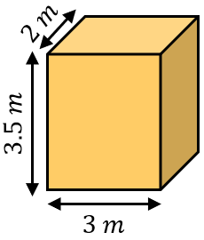
(c)

Find the surface area of these cuboids.
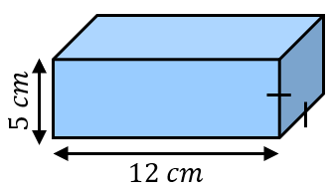
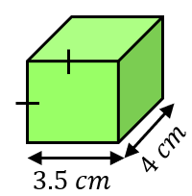
(a) (b)

(a) A cube has a side length of $x$ cm and a surface area of $337.5 {cm}^{2}$. Find $x$.
(b) A cuboid has side lengths $5 cm$, $8 cm$ and $y cm$. Its surface area is $314 {cm}^{2}$. Find $y$.
Surface Area of Cubes and Cuboids

Find the surface area of each of these cubes.
(a) (b)

(c)

Find the surface area of each of these cuboids.
(a) (b)

(c)

Find the surface area of these cuboids.
(a) (b)

(a) A cube has a side length of $x$ cm and a surface area of $337.5 {cm}^{2}$. Find $x$.
(b) A cuboid has side lengths $5 cm$, $8 cm$ and $y cm$. Its surface area is $314 {cm}^{2}$. Find $y$.

