Factor Bugs
The factors of a number are all the whole numbers (integers) that divide exactly into that number. For example, $3$ is a factor of $12$ because $12÷3=4$.
Find all the factors of 12 | Find all the factors of 20
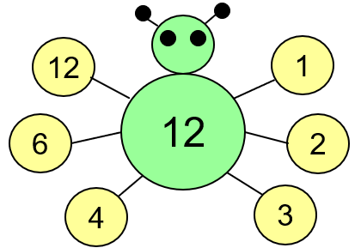  The factors of 12 are:  1, 2, 3, 4, 6 and 12 | The factors of 20 are:
Find all the factors of 32 | Find all the factors of 25
The factors of 32 are: | The factors of 25 are:
Find all the factors of 50 | Find all the factors of 13
The factors of 50 are: | The factors of 13 are:
Find all the factors of 36 | Find all the factors of 60
The factors of 36 are: | The factors of 60 are:

